FORM 6-K

SECURITIES AND EXCHANGE COMMISSION

Washington, D.C. 20549

For the month January 2024 No. 3

TOWER SEMICONDUCTOR LTD.
(Translation of registrant's name into English)

Ramat Gavriel Industrial Park
P.O. Box 619, Migdal Haemek, Israel 2310502
(Address of principal executive offices)

Indicate by check mark whether the registrant files or will file annual reports under cover Form 20-F or Form 40-F.

Form 20-F ☒ Form 40-F ☐

Indicate by check mark whether the registrant by furnishing the information contained in this Form is also thereby furnishing the information to the Commission pursuant to Rule 12g3-2(b) under the Securities Exchange Act of 1934.

Yes ☐ No ☒

On January 24, 2024, the Registrant Announces Fourth Quarter and Fiscal Year 2023
Financial Results and Conference Call

SIGNATURES

Pursuant to the requirements of the Securities Exchange Act of 1934, the registrant has duly caused this report to be signed on its behalf by the undersigned, thereunto duly authorized.

 | TOWER SEMICONDUCTOR LTD.
Date: January 24, 2024 | By: | /s/ Nati Somekh
 |  | Name: Nati Somekh
 |  | Title: Corporate Secretary

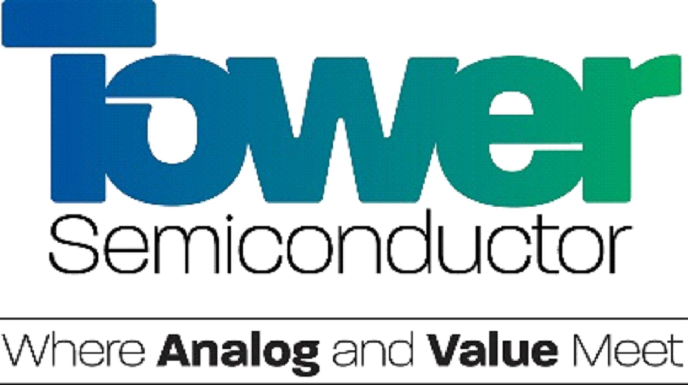

Tower Semiconductor Announces Fourth Quarter and Fiscal Year 2023 Financial Results
and Conference Call

MIGDAL HAEMEK, Israel – January 24, 2024 – Tower Semiconductor (NASDAQ/ TASE: TSEM), the leading foundry of high value analog semiconductor solutions, will issue its fourth quarter and fiscal year 2023 earnings release on Wednesday, February 14, 2024. The Company will hold a conference call to discuss its fourth quarter and fiscal year 2023 financial results and first quarter 2024 guidance on Wednesday, February 14, 2024, at 10:30 a.m. Eastern Time (09:30 a.m. Central, 08:30 a.m. Mountain, 07:30 a.m. Pacific and 05:30 p.m. Israel time).

This call will be webcasted and can be accessed through the Investor Relations section on Tower Semiconductor’s website at https://ir.towersemi.com/ or can also be accessed by calling the following numbers: U.S. Toll Free: 1-888-642-5032; Israel: 03-918-0610; International: +972-3-918-0610. The teleconference will be available for replay for 90 days.

About Tower Semiconductor
Tower Semiconductor Ltd. (NASDAQ: TSEM, TASE: TSEM), the leading foundry of high value analog semiconductor solutions, provides technology and manufacturing platforms for integrated circuits (ICs) in growing markets such as consumer, industrial, automotive, mobile, infrastructure, medical and aerospace and defense. Tower Semiconductor focuses on creating positive and sustainable impact on the world through long term partnerships and its advanced and innovative analog technology offering, comprised of a broad range of customizable process platforms such as SiGe, BiCMOS, mixed-signal/CMOS, RF CMOS, CMOS image sensor, non-imaging sensors, integrated power management (BCD and 700V), and MEMS. Tower Semiconductor also provides world-class design enablement for a quick and accurate design cycle as well as process transfer services including development, transfer, and optimization, to IDMs and fabless companies. To provide multi-fab sourcing and extended capacity for its customers, Tower Semiconductor owns two manufacturing facilities in Israel (150mm and 200mm), two in the U.S. (200mm), two facilities in Japan (200mm and 300mm) which it owns through its 51% holdings in TPSCo and is sharing a 300mm manufacturing facility in Italy with ST. For more information, please visit: www.towersemi.com.

###

Contact Information:
Tower Semiconductor Investor Relations
Noit Levy, SVP Investor Relations
noitle@towersemi.com
+972-74-7377556

