UNITED STATES
SECURITIES AND EXCHANGE COMMISSION
Washington, D.C. 20549

FORM 6-K

REPORT OF FOREIGN PRIVATE ISSUER PURSUANT TO RULE 13a-16 OR 15d-16 OF THE
SECURITIES EXCHANGE ACT OF 1934

For the month of July 2026 No.3

Commission File Number 0-24790

TOWER SEMICONDUCTOR LTD.
(Translation of registrant's name into English)

Ramat Gavriel Industrial Park
P.O. Box 619, Migdal Haemek, Israel 2310502
(Address of principal executive offices)

Indicate by check mark whether the registrant files or will file annual reports under cover of Form 20-F or Form 40-F.

Form 20-F ☒ Form 40-F ☐

On July 14, 2026, the Registrant Announces Tower Semiconductor with METI Support Announces Strategic Capacity Expansion in Japan

SIGNATURES

Pursuant to the requirements of the Securities Exchange Act of 1934, the registrant has duly caused this report to be signed on its behalf by the undersigned, thereunto duly authorized.

 | TOWER SEMICONDUCTOR LTD.
Date: July 14, 2026 | By: | /s/ Nati Somekh
 |  | Name: Nati Somekh
 |  | Title: Corporate Secretary

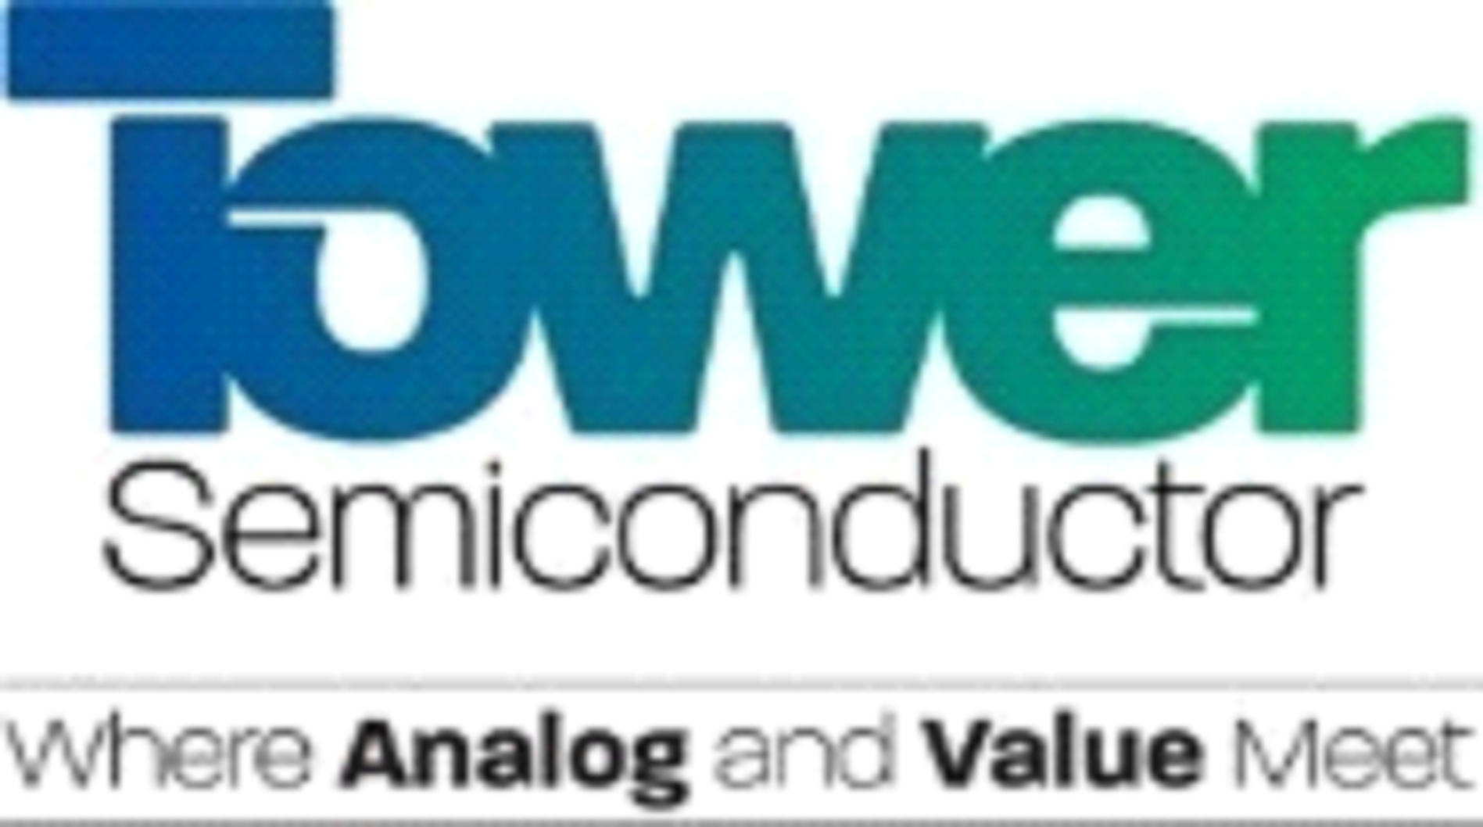

Tower Semiconductor with METI Support Announces Strategic Capacity Expansion in Japan

Significant Multiples of Silicon Photonics and Silicon Germanium Capacity to Support Accelerating Customer Demand

MIGDAL HAEMEK, Israel, July 14, 2026 – Tower Semiconductor (NASDAQ/TASE: TSEM), a leading foundry of high-value analog semiconductor solutions, today announced a parallel dual-track strategic expansion of its 300mm Silicon Photonics (SiPho), Silicon Germanium (SiGe), and advanced packaging capabilities in Japan, with support from the Government of Japan. The expansion is designed to support the rapidly growing long-term customer demand, substantially increasing the Company’s manufacturing capacity and extending its technology leadership.

Russell Ellwanger, Tower’s CEO, stated: “We are honored and appreciative that the Government of Japan has selected Tower to lead the expansion of these strategically important technologies. Together, we are building a globally differentiated center of excellence founded on technology leadership, manufacturing excellence, and exceptional product quality.

Since becoming the majority owner of the former Panasonic Semiconductor manufacturing operations, now TPSCo, this group has established a reputation for transforming cutting-edge innovation into high-volume manufacturing excellence. For these reasons, with the support of the Government of Japan, we will create a globally differentiated, advanced R&D and manufacturing center of excellence for Silicon Photonics, Silicon Germanium, and advanced optical packaging of very significant scale.

By combining Tower's specialized technology leadership with Japan's unparalleled manufacturing expertise, world-class research institutions, and deeply committed workforce, we are building a strategic platform that will drive innovation, economic growth, and semiconductor leadership for decades to come.”

Track one adds significant new 300mm Silicon Photonics capacity, with full production readiness expected during the fourth quarter of 2027. It consists of repurposing the Arai facility, formerly Fab 6, for 300mm Silicon Photonics capacity and advanced packaging capabilities, maximizing the Company’s Fab 7 300mm output in Uozu. Reflecting upon the track one growth outlook, Tower is updating its business model, targeting to achieve $3.6 billion of revenue and $1.2 billion of net profit in 2028.

Track two will commence in parallel with the first track and consists of constructing an additional 300mm manufacturing facility, adjacent to Fab 7, following signing and closing of related agreements. This facility is expected to provide a multi-fold increase in Silicon Photonics and Silicon Germanium capacity, positioning Tower to support continued accelerating customer demand for emerging AI and data center applications, driving next-generation optical connectivity requirements.

As a result of expanded customer engagements, and significant technical milestones achieved through multi-generation strategic partnerships, the new facility is expected to be highly accretive beginning in 2029, demonstrating strong leadership in the optical space, promoting long-term employee pride and strong customer satisfaction, with a business model ensuring long-term viability.

The scope of the dual-track expansion is forecasted to be an approximate $3 billion Tower’s investment, net of grants of $1 billion, to be provided by the Government of Japan. This investment creates long-term value for both Tower and Japan by establishing advanced domestic manufacturing capabilities in Silicon Photonics and Silicon Germanium, strengthening Japan’s semiconductor ecosystem and supply chain resilience.

Ellwanger further added: “Building on our long-standing relationships with Toyama and Niigata Prefectures and supported by our significant investments in the Uozu and Arai facilities, we look forward to deepening our collaboration to strengthen regional semiconductor infrastructure, expand local supply-chain capabilities, accelerate innovation, developing the next generation of highly skilled engineering and manufacturing talent, a workforce renowned for its commitment, individual ownership, dedication and loyalty.

Tower is dedicated to sustaining and creating high-quality employment, recruiting, developing, and retaining world-class engineering and manufacturing talent, expanding collaboration with local suppliers and businesses, and deepening partnerships with Japanese universities and research institutions. By strengthening these industrial and academic ecosystems, Tower seeks to drive innovation, enhance regional competitiveness, and contribute to the sustainable growth and long-term economic development of both prefectures.”

Ellwanger concluded: “The first track results in substantial increases in our updated 2028 business model. By quickly and efficiently adding capacity to an existing profitable operation, track two eliminates the timing concerns and impacts of multi cycles of learning for a greenfield qualification or a fab-to-fab product transfer, ensuring on schedule customer ramps and cash flow. We anticipate track two to provide the path for continued growth far beyond 2028.”

About Tower Semiconductor

Tower Semiconductor Ltd. (NASDAQ/TASE: TSEM), the leading foundry of high-value analog semiconductor solutions, provides technology, development, and process platforms for its customers in growing markets such as consumer, industrial, automotive, mobile, infrastructure, medical and aerospace and defense. Tower Semiconductor focuses on creating a positive and sustainable impact on the world through long-term partnerships and its advanced and innovative analog technology offering, comprised of a broad range of customizable process platforms such as SiPho, SiGe, BiCMOS, mixed-signal/CMOS, RF CMOS, CMOS image sensor, non-imaging sensors, displays, integrated power management (BCD and 700V), and MEMS. Tower Semiconductor also provides world-class design enablement for a quick and accurate design cycle as well as process transfer services including development, transfer, and optimization, to IDMs and fabless companies. To provide multi-fab sourcing and extended capacity for its customers, Tower Semiconductor currently owns one operating facility in Israel (200mm), two in the U.S. (200mm), and two in Japan (200mm and 300mm) which it owns through its 51% holdings in TPSCo and shares a 300mm facility in Agrate, Italy with STMicroelectronics. For more information, please visit: www.towersemi.com.

Forward-Looking Statements

This release, as well as other statements and reports filed, stated and published, include certain “forward-looking” statements within the meaning of Section 21E of the Securities Exchange Act of 1934, as amended. These forward-looking statements include, among others, projections and statements with respect to our future business, financial performance and activities. The use of words such as “projects”, “expects”, “may”, “targets”, “plans”, “forecast”, “intends”, “committed to”, “tracking”, or variations or words of similar import, may identify a statement as “forward-looking.” However, the absence of these words does not mean that a statement is not forward-looking. Actual results may vary from those projected or implied by such forward-looking statements and you should not unduly rely on such forward-looking statements, which speak only as of the date of this release. Factors that could cause actual results to differ materially from those projected or implied by such forward-looking statements include, without limitation, risks and uncertainties associated with: (i) fluctuating demand in our customers’ end markets and/or SiPho, SiGe and other customer demand may not increase to the levels currently forecasted by the Company, (ii) reliance on acquisitions, establishing new fabs and/or gaining additional capacity for growth, (iii) difficulties in achieving acceptable operational metrics and indices as a result of operational, technological or process-related problems, (iv) identifying and negotiating with third-party buyers for the sale of any excess and/or unused equipment, inventory and/or other assets, (v) maintaining current key customers and attracting new key customers, (vi) over demand for our foundry services and/ or products that may result in operational bottlenecks, extend cycle times, reduce yield, delay delivery schedules, that may result in compensation, penalties and/ or prepayment repayments, loss of customers, revenues, profits and/ or reputation, including with respect to SiPho customer prepayments received for certain minimum capacity commitments, due to inability to fulfill, in whole or in part, all such demand and commitments in a timely manner or at all, (vii) fluctuation of our financial results from quarter to quarter, (viii) the additional 300mm manufacturing facility the Company plans to establish adjacent to Fab 7 and maximization of the Company’s Fab 7 300mm output (including risks associated with the repurposing of the Arai facility), including risks associated with delays in construction period and cost, obtaining necessary equipment and/ or obtaining necessary permits, Government of Japan and/or METI grants terms and covenants thereto (which may result in loss of a portion or all of the grant funds), and/ or other consents required, and the negotiation of definitive agreements with vendors and others, that may result in lower profitability than currently expected and/ or added costs and losses, longer return on investment period, including risks associated with the ability to obtain any financing required to fund the establishment, facilities and machinery cost net investments on favorable terms, or at all, (ix) our debt and other liabilities may impact our financial position and operations, (x) our ability to successfully execute acquisitions, integrate them into our business, utilize our expanded capacity and find new business, (xi) fluctuations in cash flow, (xii) our ability to satisfy the covenants stipulated in our agreements with our debt holders and/ or possible incurrence of additional indebtedness, (xiii) pending litigation, (xiv) meeting the conditions set in approval certificates and other regulations under which we received grants and/or royalties and/or any type of funding from the Israeli, US and/or Japan governmental agencies, (xv) receipt of orders that are lower than the customer purchase commitments or forecast and/or failure to receive customer orders currently expected, (xvi) the effects of global recession, credit crisis and/or unfavorable macro-economic conditions, such as the imposition of regulatory requirements, tariffs, import and export restrictions and other trade barriers and restrictions, including the timing and availability of export licenses and permits, (xvii) our ability to accurately forecast financial performance, which is affected by limited order backlog and lengthy sales cycles which may cause financial results to fluctuate from quarter to quarter, (xviii) possible situations of obsolete inventory or overcapacity if forecasted demand exceeds actual demand when we create inventory before receipt of customer orders, (xix) the cyclical nature of the semiconductor industry and the resulting periodic overcapacity, fluctuations in operating results and future average selling price erosion, (xx) capacity and capability expansion and acquisition related transactions in our existing fabrications, strategic and/or other in-organic capacity and/ or capability growth and/ or M&A transactions and opportunities, and/ or the acquisition of and/ or the establishment of a new factory or factories, including the additional 300mm manufacturing facility the Company plans to establish adjacent to Fab 7 and maximization of the Company’s Fab 7 300mm output (including risks associated with the repurposing of the Arai facility), which could require funding needs beyond our existing cash, the availability of which cannot be assured on favorable terms, if at all, and which may have adverse impact on the market value of the Company and the price of the Company’s ordinary shares, (xxi) operating our facilities at sufficient utilization rates necessary to generate and maintain positive and sustainable gross, operating and net profit, (xxii) the purchase of equipment and/or raw material (including purchases under committed contracts), the timely completion of the equipment installation, technology transfer and raising the funds therefor, (xxiii) product returns and defective products, (xxiv) our ability to maintain and develop our technology processes and services to keep pace with new technology, including artificial intelligence, evolving standards, changing customer and end-user requirements, new product introductions and short product life cycles, (xxv) competing effectively, (xxvi) our dependence on increased use of outsourced foundry services for specialty process technologies, (xxvii) our dependence on intellectual property rights of others, our ability to operate our business without infringing others’ intellectual property rights and our ability to enforce our intellectual property against infringement, including risks and uncertainties associated with the three infringement claims that the Company is currently party to, brought by GlobalFoundries alleging infringement of certain of its patents, (xxviii) Fab 3 landlord’s alleged claims regarding noise abatement and request for judicial declaration of material non-curable breach of the Fab3 lease, and in addition, claims by a third-party with whom the landlord is engaged pertaining to the Fab3 site, where such third party believes he has certain rights with respect to the lease extension, (xxix) retention of key employees and recruitment and retention of skilled qualified personnel, (xxx) exposure to inflation, currency rates (mainly the Israeli Shekel and the Japanese Yen) and interest rate fluctuations and risks associated with doing business locally and internationally, as well as fluctuations in the market price of our traded securities, (xxxi) meeting regulatory requirements worldwide, including export, environmental and governmental regulations, as well as risks related to international operations, (xxxii) engagements for fab establishment, joint venture and/or capital lease transactions for capacity enhancement in advanced technologies, including risks and uncertainties associated with the Agrate fab, such as its qualification schedule, technology, equipment and process qualification, facility operational ramp-up, customer engagements, cost structure, required investments and other terms, which may require additional funding to cover significant capacity investment needs and other payments, (xxxiii) potential liabilities, cost and other impact due to reorganization and consolidation of fabrication facilities, or cessation of operations, (xxxiv) potential security, cyber and privacy breaches, (xxxv) workforce that is not unionized which may become unionized, and/or workforce that is unionized and may take action such as strikes that may create increased cost and operational risks, (xxxvi) the issuance of ordinary shares as a result of exercise and/or vesting of any of our employee equity, as well as any sale of shares by any of our shareholders, or any market expectation thereof, as well as the issuance of additional employees’ restricted stock units, or any market expectation thereof, which may depress the market value of the Company and the price of the Company’s ordinary shares, and in addition may impair our ability to raise future capital, (xxxvii) the dispute resolution process with involving Intel’s determination not to perform its agreement to build a capacity corridor to enable Intel to manufacture wafers for Tower’s customers, which process may be costly and/ or may result in losses and/or other adverse impact, (xxxviii) Pillar Two tax rules and regulations previously released by the OECD, which require a minimum effective corporate income tax rate of 15% applicable in every jurisdiction in which the company operates, which will result in additional income tax expenses for the years 2026 and beyond, mainly with respect to the Company’s Israeli operations in which the Company was subject to 7.5% preferred tax rate until 2025 under Israeli laws, and (xxxix) climate change, business interruptions due to floods, fires, pandemics, earthquakes and other natural disasters, the security situation in Israel and global trade “war”, including the potential inability to continue uninterrupted operations of the Israeli fab, impact on global supply chain to and from the Israeli fab, delays in the delivery, installation and qualification of equipment, power interruptions, chemicals or other leaks or damages as a result therefrom, absence of workforce due to military service as well as risk that certain countries will restrict doing business with Israeli companies, including imposing restrictions due to hostilities in Israel or political instability in the region that may continue or exacerbate, and other events beyond our control. Due to hostilities and instability in neighboring states, Israel could be subject to additional political, economic, and military confines, and our Israeli facility’s operations could be materially adversely affected. Any current or future hostilities involving Israel or the interruption or curtailment of trade between Israel and its present trading partners, or a significant downturn in the economic or financial condition of Israel, could have a material adverse effect on our business, financial condition and results of operations.

A more complete discussion of risks and uncertainties that may affect the forward-looking statements included in this release or which may otherwise affect our business is included under the heading "Risk Factors" in the Company’s most recent filings on Forms 20-F and 6-K, as were filed with the SEC and the Israel Securities Authority. Future results may differ materially from those previously reported. The Company does not intend to update and expressly disclaims any obligation to update or revise any forward-looking information contained in this release to reflect any changes in expectations with regard thereto, or any change in events, conditions or circumstances on which any such statement is based.

###

Tower Semiconductor Company Contact: Orit Shahar | +972-74-7377440 | oritsha@towersemi.com
Tower Semiconductor Investor Relations Contact: Liat Avraham | +972-4-6506154 | liatavra@towersemi.com

