Filed by Tower Semiconductor Ltd.

Pursuant to Rule 425 under the Securities Act of 1933

And Deemed Filed Pursuant to Rule 14a-12

Under the Securities Exchange Act of 1934

Filer's Commission File No. 000-24790

Subject Company: Jazz Technologies, Inc.

Commission File No. 001-32832

The slides contained in this filing were used in a presentation given to media and analysts on July 9, 2008, hosted by Russell C. Ellwanger, the Chief Executive Officer of Tower Semiconductor Ltd.
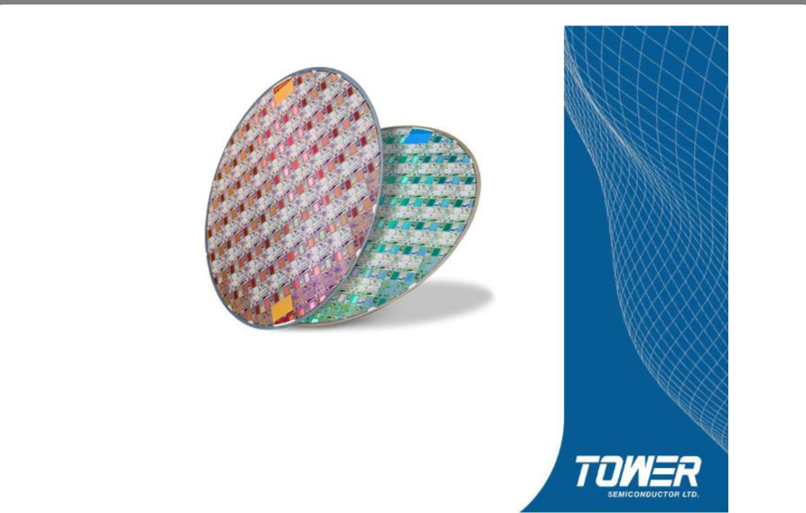

Tower Semiconductor

Collins Stewart

July 9, 2008

Forward Looking Statements

The information presented today contains forward-looking statements that relate to anticipated future operating results. Those statements are based on management’s current expectations and assumptions, which may be affected by subsequent developments and business conditions, and necessarily involve risks and uncertainties. Therefore, there can be no assurance that actual future results will not differ materially from anticipated results.

For a discussion of risks and uncertainties that may affect the accuracy of forward-looking statements or which may otherwise affect our business, please see the information included under the heading "Risk Factors" in our most recent filings on Forms 20-F, F-1, F-3 and 6-K, as were filed with the Securities and Exchange Commission and the Israel Securities Authority.

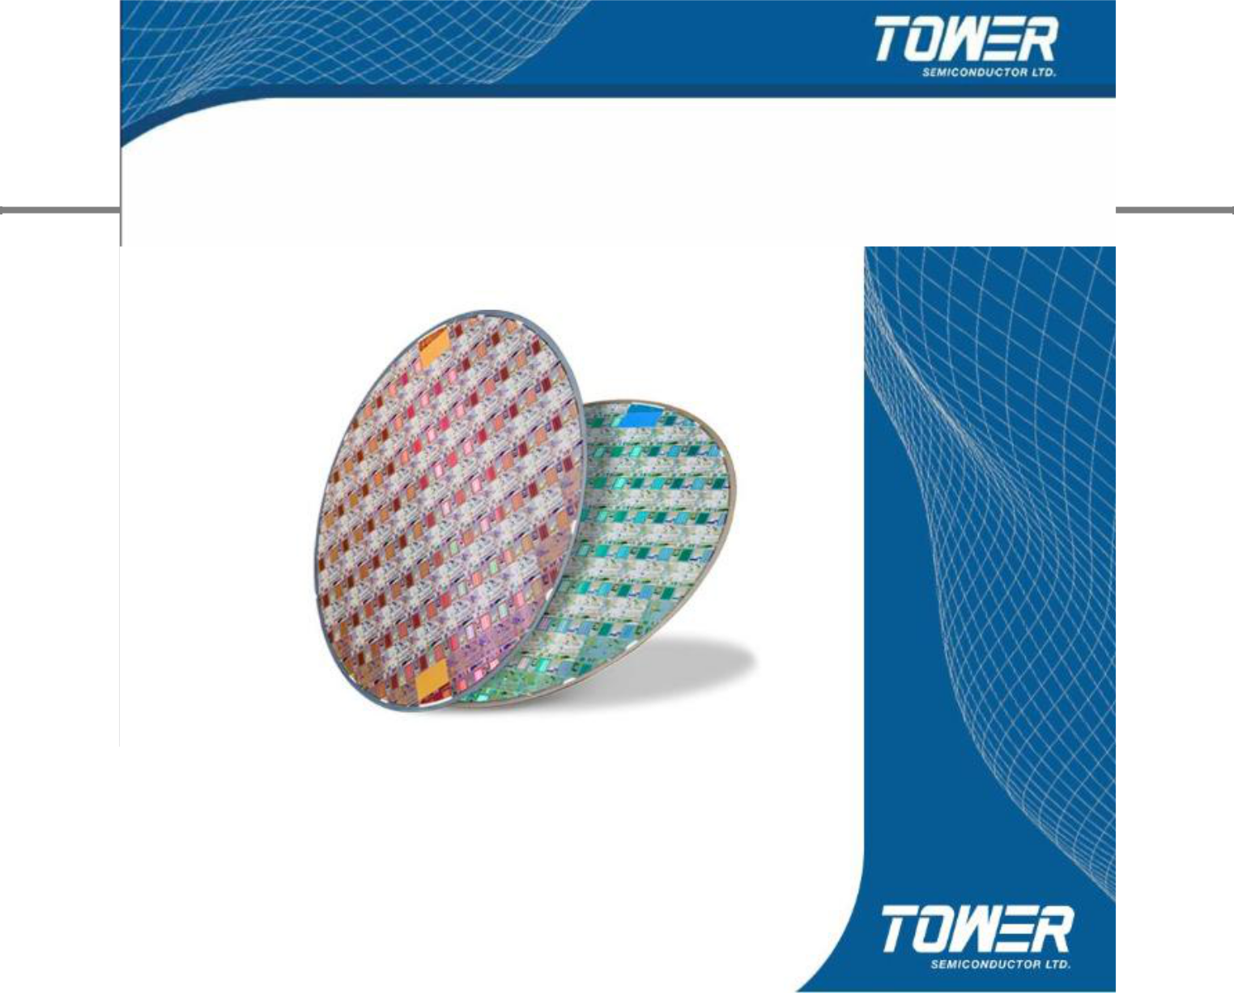
2

Tower Financials

3

Revenue and EBITDA

(in $millions) | 2005 | 2007 |  |  |  |  |  | 61.6
(in $millions) | 2005 | 2007 |  |  |  |  |  | 57.6 | 58**
Revenues | $94 | $231 | $137 | 55.5 | 55.6 | 57.1 | 56.6 | 57.6 | 58**
EBITDA | ($26) | $49 | $75
EBITDA / Revenues |  |  | 51.5
 |  |  | 55%
 |  |  | 44.6
 |  | 35.9
Revenues | 31.1 |  | Ebitda positive |  |  | Cash flow
Revenues |  |  | since Q4’05; |  |  | positive since
(in $M) |  |  | since Q4’05;
(in $M) |  |  | EBITDA qtr. |  |  | Q4’06; Cash
 |  |  | run rate since | Positive Cash |  | flow qtr. run rate
20.6 | Positive EBITDA |  | -$10M in ’05, |  |  | since | -$16M in
20.6 |  |  | -$10M in ’05, | from Operations |  | since | -$16M in
20.6 |  |  | to +$12M |  |  | ’05, to +$4M
19.2
in ‘07

in ’07

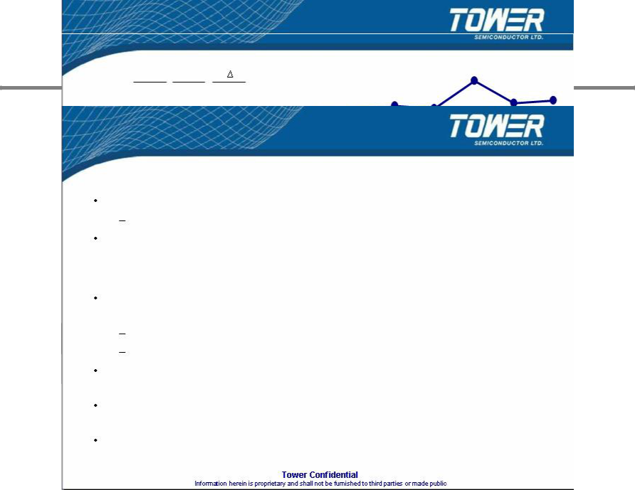
Q2'05 Q3'05 Q4'05 Q1'06 Q2'06 Q3'06 Q4'06 Q1'07 Q2'07 Q3'07 Q4'07 Q1'08 Q2'08

- Q205 data excludes $8M effect from a Fab2 technology agreement ** Midrange of company guidance

4

Q1- 2008 Financial Results

Financial Highlights

Achieved revenue of $57.6M

2nd highest quarterly revenue in the Company’s history

Positive cash flow from operations for the 6th consecutive quarter and positive EBITDA for the 10th consecutive quarter

Major Announcements

Tower Semiconductor Chosen as Strategic Supplier for a Select Portfolio of CMOS Products by ON Semiconductor:
Launch a Multi-Year and Potentially Multi-Million Dollar Collaboration Project Co-develop and manufacture multiple lines of products

Ramping to production of Canesta’s 3D Image Sensors in Fab 2 targeted at the automotive and gaming / 3D camera market
Initiated production of N-trig’s Digitizer Chips in Fab 2 targeted at the convertible notebook market

Tower Semiconductor to Launch Volume Production of QuickLogic's ArcticLink II VX Solution Platforms for Mobile Display Devices

5

Foundry Revenue 2005-6-7

(in $M) | 2005 |  | 2006 |  | 2007
A | TSMC | 8217 | TSMC | 9748 | TSMC | 9813
B | UMC | 3259 | UMC | 3670 | UMC | 3755
C | SMIC | 1171 | Chartered | 1528 | SMIC | 1560
D | Chartered | 1132 | SMIC | 1465 | Chartered | 1445
1 | Vanguard | 353 | Dongbu | 456 | Dongbu | 510
2 | Dongbu | 347 | Vanguard | 398 | Vanguard | 485
3 | HHNEC | 313 | SSMC | 325 | X-Fab | 410
4 | SSMC | 280 | HHNEC | 315 | SSMC | 350
5 | He Jian | 250 | X-Fab | 290 | HHNEC | 335
6 | X-Fab | 202 | He Jian | 290 | He Jian | 330
7 | Jazz | 199 | Jazz | 213 | Tower | 231
8 | Mosel-Vitelic | 140 | Grace | 191 | Jazz | 207
9 | Silterra | 130 | Tower | 187 | Grace | 214
10 | ASMC | 114 | ASMC | 170 | Silterra | 185
11 | Grace | 100 | Silterra | 155 | ASMC | 170
12 | Tower | 94 | Mosel-Vitelic | 155 | Mosel-Vitelic | 157
13 | Polar Semi. | 90 | CSMC Tech. | 114 | CSMC Tech. | 155
14 | CSMC Tech. | 78 | Polar Semi. | 95 | Polar Semi. | 105
15 | 1st Silicon | 71 | 1st Silicon | 0 | 1st Silicon | 0

16+ Others 105 Others 139 Others 163

6
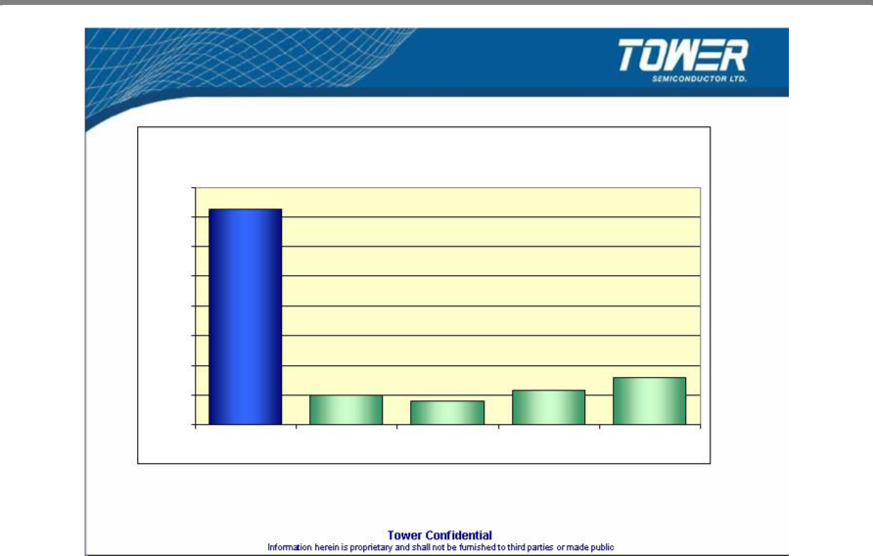

Tower Revenues vs. Leading Foundries

2007 vs. 2005 Revenue Growth

160%
146%
140%
120%
100%
80%
60%
40% |  |  |  | 31%
40% | 20% |  | 23%
 | 20% | 16% | 23%
20% |  | 16%
0%
Tower | TSMC | UMC | SMIC | CHRT

* 2005 data excludes $8M effect from a Fab2 technology agreement

7
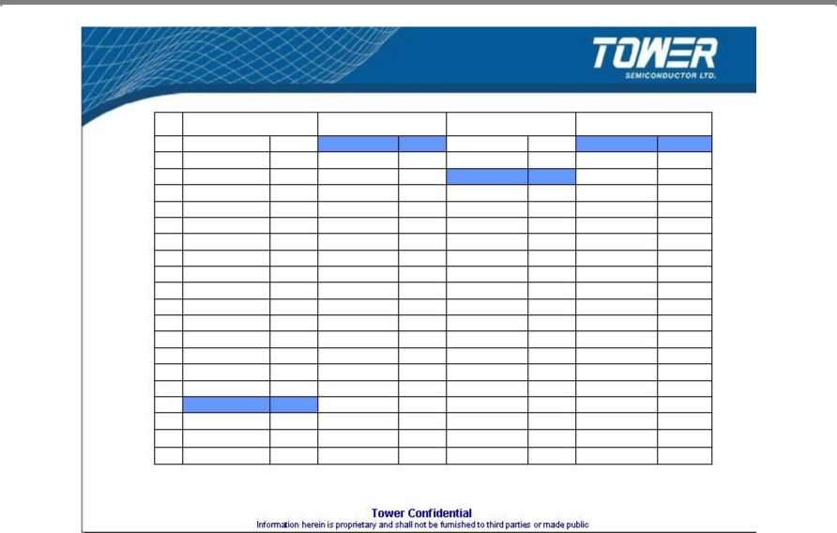

Foundry Revenue Growth Y/Y

 | 05vs04 |  | 06vs05 |  | 07vs06 |  | 07vs05
1 | Dongbu | 52% | Tower | 99% | X-Fab | 41% | Tower | 146%
2 | Others | 38% | Grace | 91% | CSMC Tech. | 36% | Grace | 114%
3 | SMIC | 20% | ASMC | 49% | Tower | 24% | X-Fab | 103%
4 | X-Fab | 14% | CSMC Tech. | 46% | Vanguard | 22% | CSMC Tech. | 99%
5 | He Jian | 9% | X-Fab | 44% | Silterra | 19% | Others | 55%
6 | SSMC | 8% | Chartered | 35% | Others | 17% | ASMC | 49%
7 | TSMC | 7% | Others | 32% | He Jian | 14% | Dongbu | 47%
8 | Chartered | 3% | Dongbu | 31% | Grace | 12% | Silterra | 42%
9 | Polar Semi. | -2% | SMIC | 25% | Dongbu | 12% | Vanguard | 37%
10 | CSMC Tech. | -3% | Silterra | 19% | Polar Semi. | 11% | SMIC | 33%
11 | HHNEC | -3% | TSMC | 19% | SSMC | 8% | He Jian | 32%
12 | ASMC | -9% | SSMC | 16% | Jazz | 8% | Chartered | 28%
13 | Jazz | -10% | He Jian | 16% | SMIC | 6% | SSMC | 25%
14 | Silterra | -13% | Vanguard | 13% | HHNEC | 6% | TSMC | 19%
15 | 1st Silicon | -15% | UMC | 13% | UMC | 2% | Polar Semi. | 17%
16 | UMC | -16% | Jazz | 7% | TSMC | 1% | Jazz | 16%
17 | Tower | -24% | Polar Semi. | 6% | Mosel-Vitelic | 1% | UMC | 15%
18 | Vanguard | -26% | HHNEC | 1% | ASMC | 0% | HHNEC | 7%
19 | Grace | -31% | 1st Silicon | NA | Chartered | -5% | Mosel-Vitelic | NA
20 | Mosel-Vitelic | NA | Mosel-Vitelic | NA | 1st Silicon | NA | 1st Silicon | NA

Source: The McLean Report, 2008 edition

8
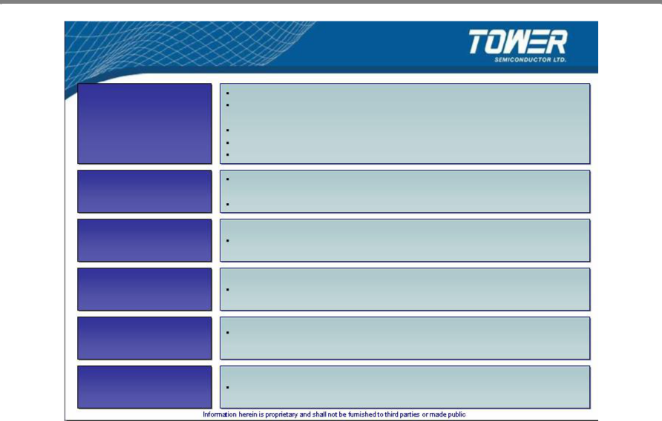

What Will Fuel Our Organic Growth

0.13u Capacity

Utilization

Growth

IDM

CMT Joint

Venture

Power

Management

RFID

New project with existing high volume 0.13um customer

Existing very large volume customer has taped out 0.13u product with

volume ramp expected to start in Q1-09
Return customer (large IDM) expected to tape out in Q4-08 0.13u cross sales from Jazz customers

Mid 2009, greater than 10,000 wpm potential

Multiple IDM transfers in stages of growth, as well as new opportunities in

several stages of closure
Porting from fab closure for large volume customer

First product has fab’ed out and being evaluated

Won the 1st customer project with new power management platform

Increased world wide RFID activity including prototype activities with 2 industry leading Chinese customers

Image Sensors Continue to gain design wins for multiple Image Sensors applications

9
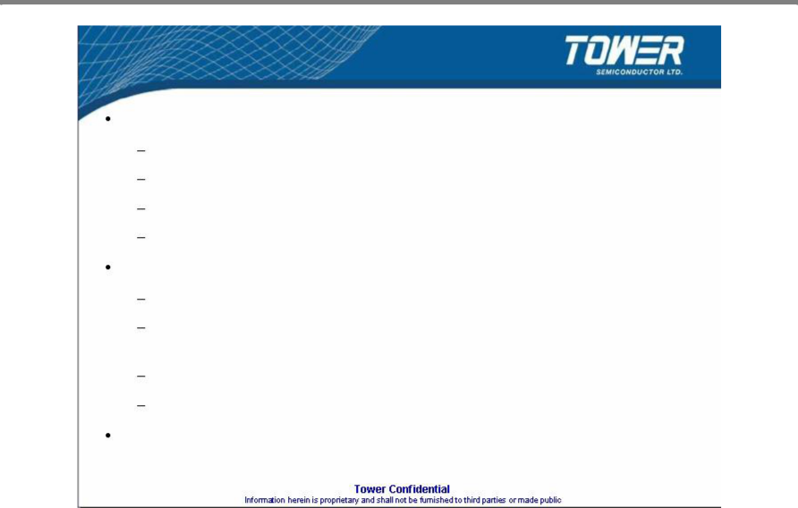

Summary of Tower Stand Alone

2006 was a breakout year for Tower

99% annual growth vs. foundry industry weighed average growth of 25%

Achieved consecutive quarterly record sales

Achieved positive EBITDA in all quarters

Achieved positive cash from operations in Q4’06, per target

2007-2008 continues the momentum

2007 YTD year-over-year 23% up vs. industry up 3%

Q1-2008 revenue of $57.6M, representing the 2nd highest quarterly revenue in the Company’s history

Achieved positive EBITDA in all quarters

Achieved positive cash from operations in all quarters

Several new growth opportunities at various stages incorporating Tower’s design and specialty manufacturing capabilities

10
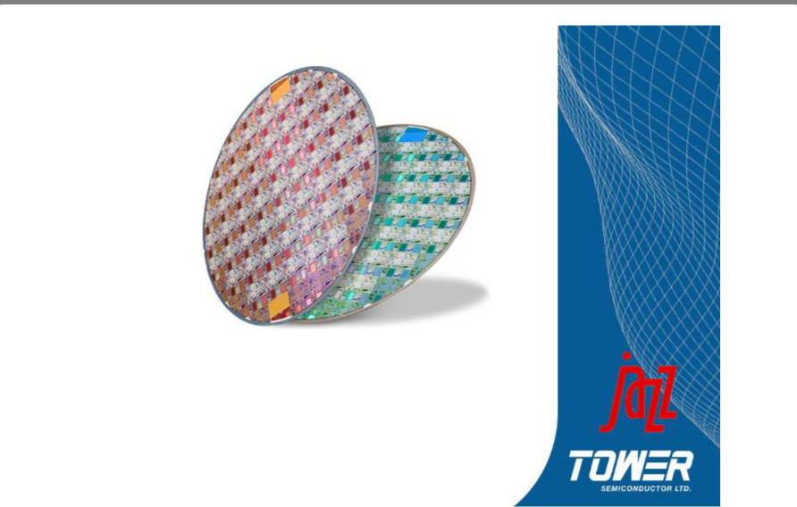

Tower Semiconductor

and

Jazz Technologies

Creating the Leading Specialty Foundry

11
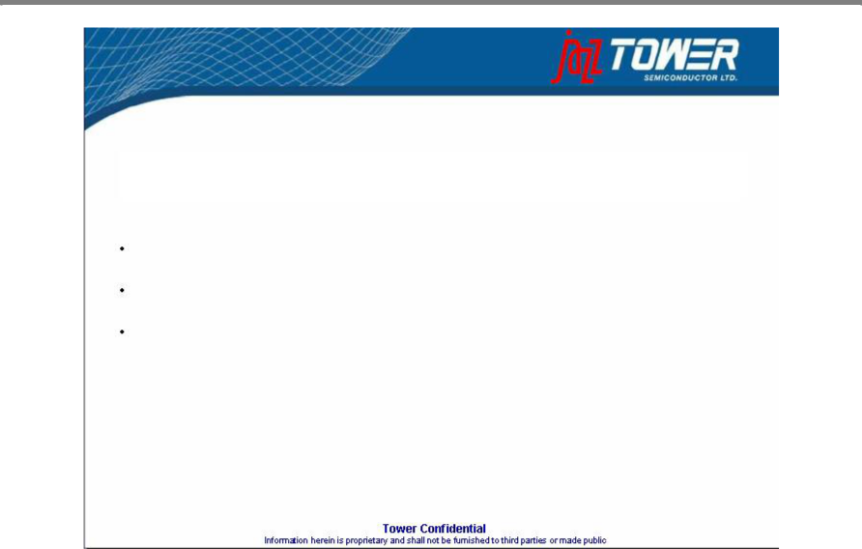

Transaction Overview

Tower Semiconductor has signed a definitive agreement to acquire Jazz Technologies in a stock-for-stock transaction

Jazz shareholders to receive 1.8 shares of Tower for each Jazz share Customary closing conditions including Jazz shareholder approval

Expected to close in 2nd half 2008

Merger is expected to create the leading pure-play specialty foundry and #7 overall pure-play foundry

12

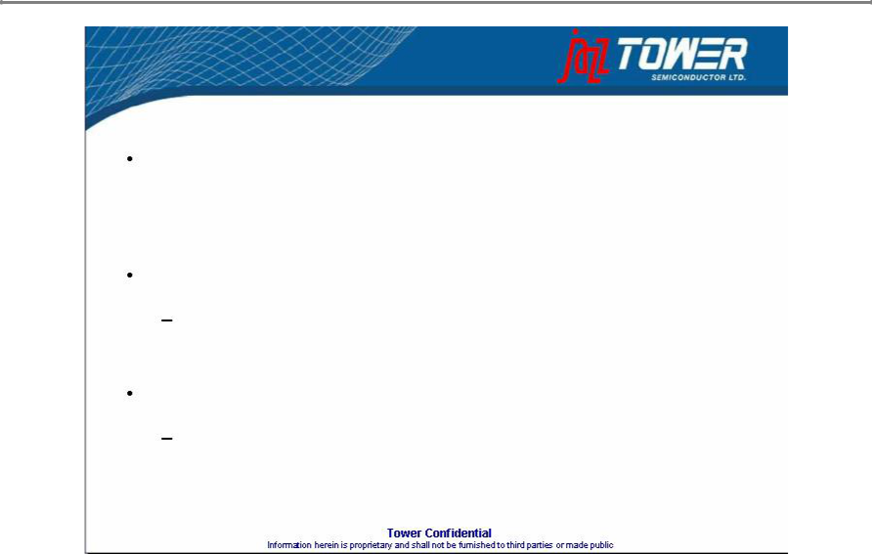
What will fuel our growth (Jazz merger)

Combined company will improve sales & EBITDA by 2X-2.5X from Day1

Jazz customers synergies

See next slides

Jazz growth

See next slides

13
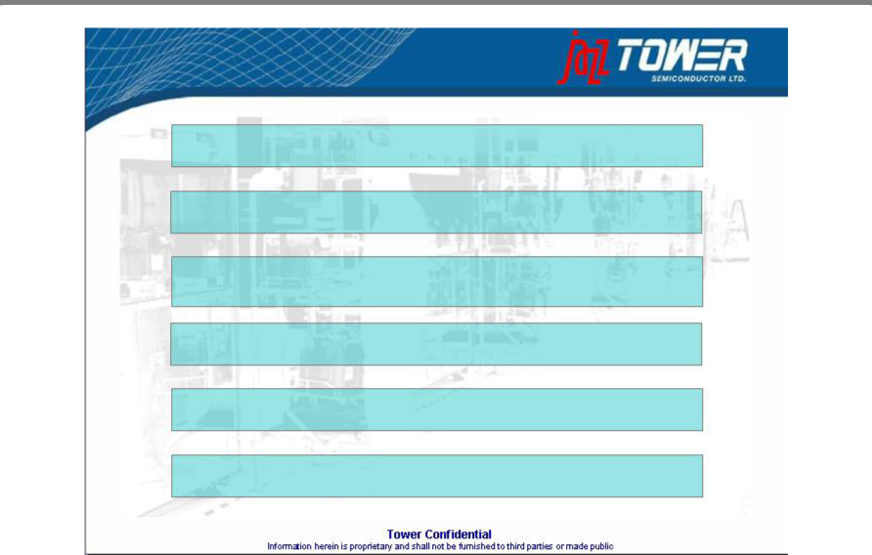

Creating the Leading Specialty Foundry

Increased Capacity and Scale to Attract Larger Customers

Global Presence Improves Geographic Reach and Distribution

Leadership In Specialty Process Technologies:

CMOS Image Sensor, SiGe, Power Mgmt, NVM, RF-CMOS, BCD

Synergies of Value Add Technologies Enables Higher Margins

Diverse Customer Base in High Growth Markets

Significant Synergy Potential Both on Revenues and Expenses

14

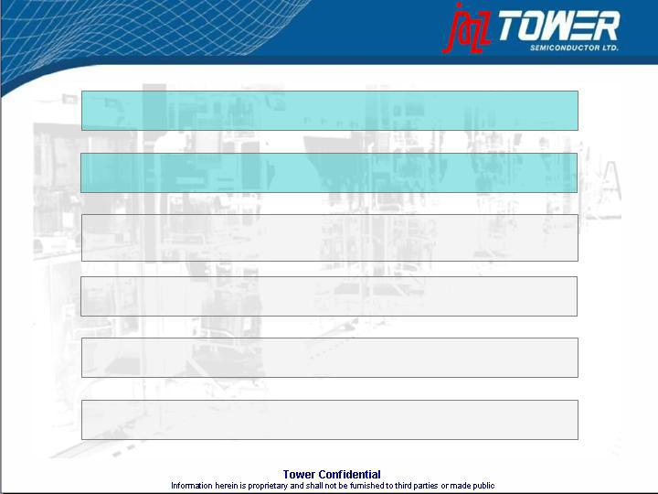
Creating the Leading Specialty Foundry

Increased Capacity and Scale to Attract Larger Customers

Global Presence Improves Geographic Reach and Distribution

Leadership In Specialty Process Technologies:

CMOS Image Sensor, SiGe, Power Mgmt, NVM, RF-CMOS, BCD

Synergies of Value Add Technologies Enables Higher Margins

Diverse Customer Base in High Growth Markets

Significant Synergy Potential Both on Revenues and Expenses

15
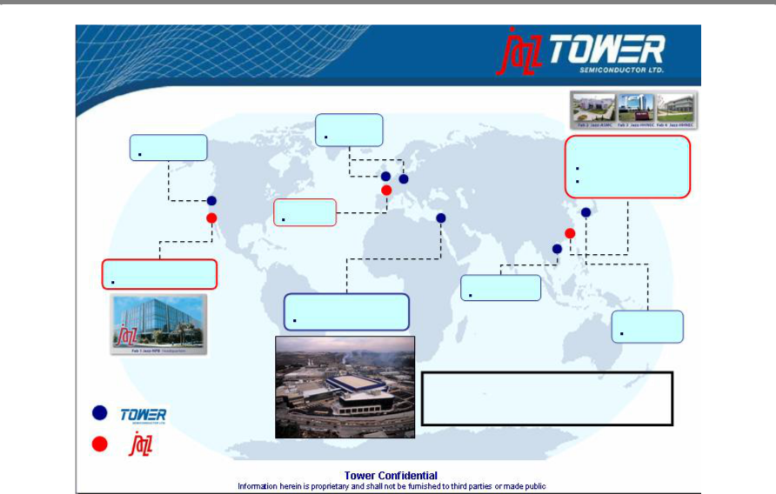

Global Infrastructure

 | UK & Holland
Santa Clara, CA | Sales reps

~70K WPY

Sales office | Shanghai, China
 | HHNEC: 10% ownership
 | ASMC: supply agreement
UK
Sales office
Newport Beach, CA
8” Fab | Hsinchu, Taiwan
Migdal HaEmek, Israel | Rep. office
8” Fab & 6” Fab | Tokyo, Japan
 | Rep. office
200K WPY
 | Total 8” equivalent capacity of
 | ~750K WPY
480K WPY

16

Overview of Jazz’s Key Assets
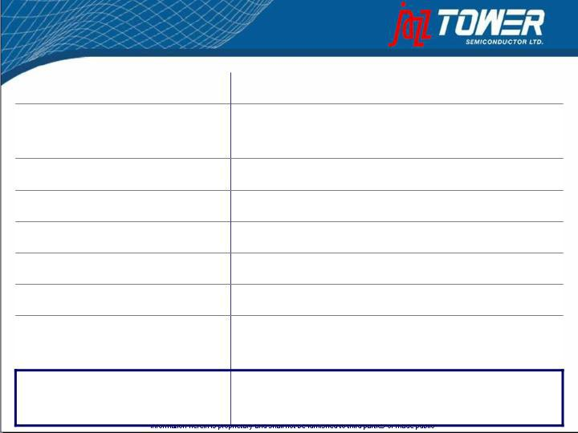

Asset

Available Unused Credit Bank Facility

Accounts Receivable, net Inventory, net

Property, Plant & Equipment, net Intellectual Property Cash

10% Stake in Chinese Fab (HHNEC)

Balance Sheet Value

Value as at Mar 28, 2008

$34 million

$26 million

$13 million

$121 million ($79 million is machinery and equipment)

$18 million book value

$9 million

$19 million book value (market value materially higher)

$249 million book value (market value materially higher)

17
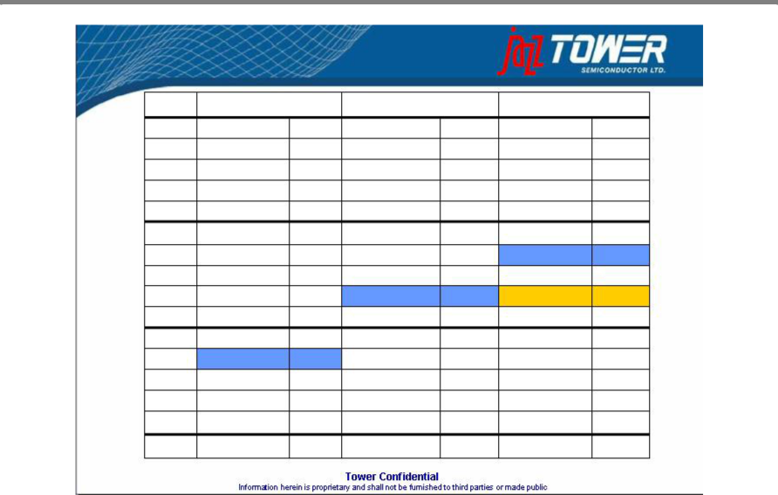

Foundry Revenue 2005-6-7

(in $M) | 2005 |  | 2006 |  | 2007
1 | Vanguard | 353 | Dongbu | 456 | Dongbu | 510
2 | Dongbu | 347 | Vanguard | 398 | Vanguard | 485
3 | HHNEC | 313 | SSMC | 325 | X-Fab | 410
4 | SSMC | 280 | HHNEC | 315 | SSMC | 350
5 | He Jian | 250 | X-Fab | 290 | HHNEC | 335
6 | X-Fab | 202 | He Jian | 290 | He Jian | 330
7 | Jazz | 199 | Jazz | 213 | Tower | 231
8 | Mosel-Vitelic | 140 | Grace | 191 | Grace | 214
9 | Silterra | 130 | Tower | 187 | Jazz | 207
10 | ASMC | 114 | ASMC | 170 | Silterra | 185
11 | Grace | 100 | Silterra | 155 | ASMC | 170
12 | Tower | 94 | Mosel-Vitelic | 155 | Mosel-Vitelic | 157
13 | Polar Semi. | 90 | CSMC Tech. | 114 | CSMC Tech. | 155
14 | CSMC Tech. | 78 | Polar Semi. | 95 | Polar Semi. | 105
15 | 1st Silicon | 71 | 1st Silicon | 0 | 1st Silicon | 0
16+ | Others | 105 | Others | 139 | Others | 163

Source: The McLean Report, 2008 edition

18

3rd Largest Pure Play Specialty Foundry

Company | 2007 Sales ($M)
Dongbu | $510
Vanguard | $486
 | $438
X-Fab | $410
SSMC | $350
HHNEC | $335
He Jian | $330
Grace | $214
Silterra | $185
ASMC | $170
Mosel Vitelics | $157
CSMC | $155
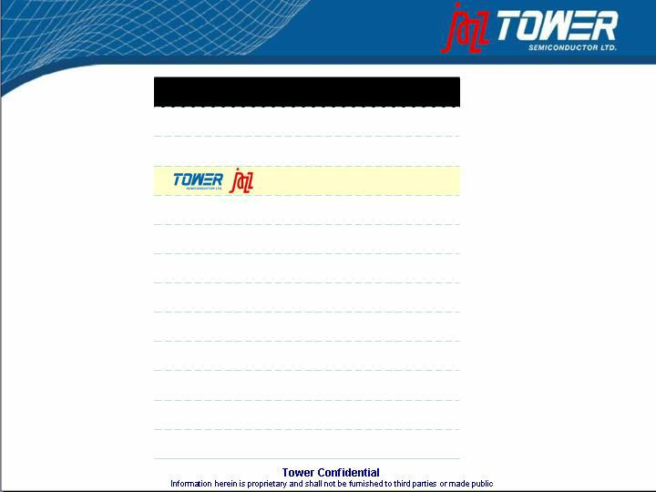
Tower / Jazz is Pro Forma

Source: IC Insights 5/2008

19
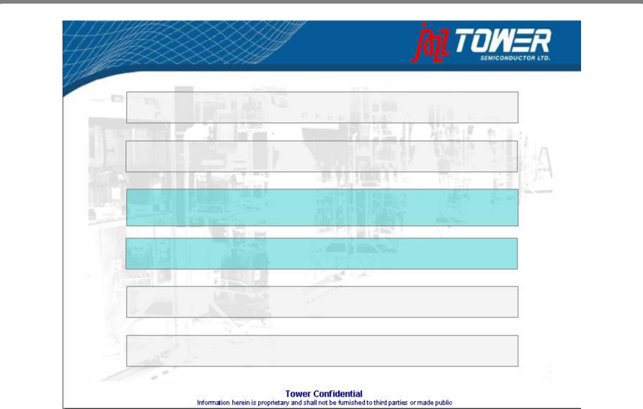

Creating the Leading Specialty Foundry

Increased Capacity and Scale to Attract Larger Customers

Global Presence Improves Geographic Reach and Distribution

Leadership In Specialty Process Technologies:

CMOS Image Sensor, SiGe, Power Mgmt, NVM, RF-CMOS, BCD

Synergies of Value Add Technologies Enables Higher Margins

Diverse Customer Base in High Growth Markets

Significant Synergy Potential Both on Revenues and Expenses

20

Post Merger Process Portfolio Lineup

 | From Jazz | From Tower | Tower/Jazz
 | Technology Node
0.50µm | 0.35µm | 0.25µm | 0.18µm | 0.16 / 0.13µm
 | BiCMOS, SiGe | SiGe | SiGe | SiGe
Power/ BCD (40V) | BCD (40V) | BCD (40V) | Power/BCD (40V)
 | RF CMOS | RF CMOS | RFCMOS | RF CMOS
Image Sensor | Image Sensor |  | Image Sensor
( X-Ray& Visible) | (X-Ray & Visible) |  | (X-Ray & Visible)
eNVM |  |  | eNVM
Mixed Signal | Mixed Signal | Mixed Signal | Mixed Signal | Mixed Signal
Digital CMOS | Digital CMOS | Digital CMOS | Digital CMOS | Digital CMOS
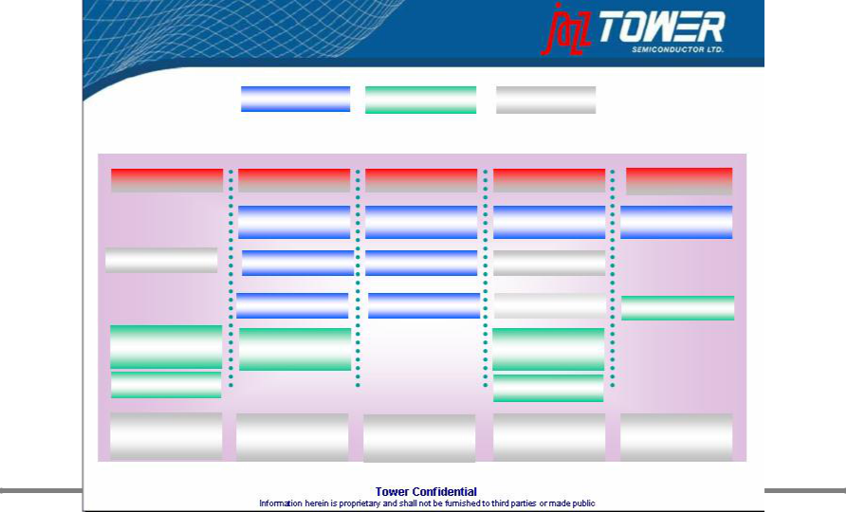

21
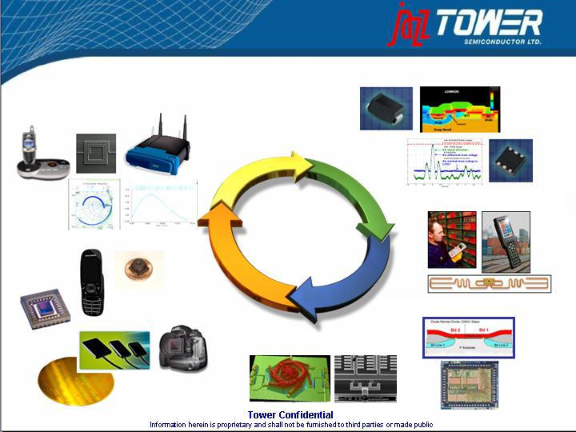

The Specialty Foundry

AIMS & RF

(SiGe & RFCMOS)

Power Management

RFID

 | Specialty
 | Foundry
CMOS Image | eNVM
Sensors | eNVM
 | MEMS

22

The Specialty Foundry

AIMS & RF

Power Management

(SiGe & RFCMOS)
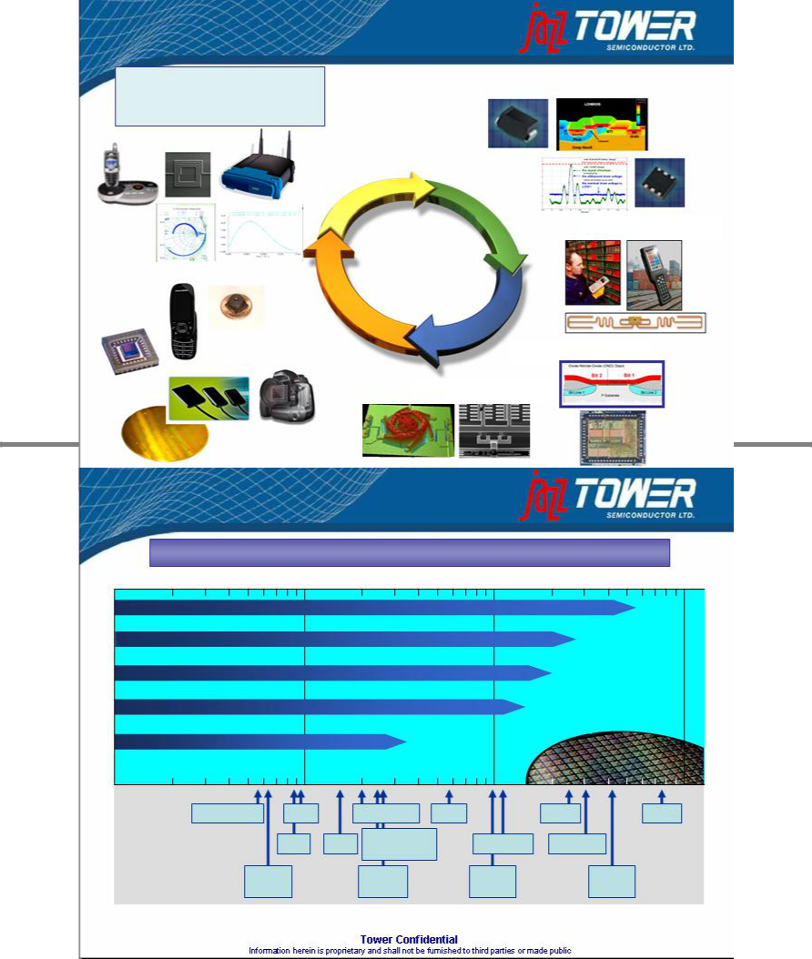

RFID

 | Specialty
 | Foundry
CMOS Image | eNVM
Sensors | eNVM
 | MEMS

23

Application vs. Process Technology

Every high-frequency application can be served through the combined offering

100 MHz |  | 1 GHz |  |  |  | 10 GHz |  | 100 GHz
SBC18H2 | ft/fmax > 200 GHz
SBC18HX | ft/fmax > 150 GHz
SBC18PT | ft/fmax > 120 GHz
SBC35QTL | ft/fmax > 60 GHz
BC35 | ft/fmax > 25 GHz |  |  |  |  |  | Operating Frequency (GHz)
.2 | .3.4 .5 .6 | .7 .8 .9 |  | 2 | 34 | 5 6 7 8 9 | 2030 40 50 | 60 70 8090
 | Terrestrial TV | GSM |  | DECT/UMTS |  | UWB | Radar | Radar
 |  | RKE | GPS | WLAN/WiMAX |  | DBS (SAT) | MW Radio
 |  |  |  |  | Bluetooth
 | 62 Mb/s |  |  | 2.5 Gb/s |  | 10 Gb/s | 40 Gb/s
 | OC 12 |  |  |  | OC 48 | OC 192 | OC 768

24

Silicon Radio Platform

Single Chip Silicon FEM

 |  |  |  | PA Frequency / Performance
 | FEM |  |  |  |  |  | CP05, SBC35
 | FEM |  |  | UWB |  |  |  | SBC18QPA
Today |  | Future Integration: |  | 5.8G DCT | 802.11a,n
Silicon | Antenna | Silicon Radio Platform |  | Bluetooth ^{PHS} |  | WiMax
Non-Silicon | Antenna |  |  |  |  |  |  | WCDMA/EDGE
 |  |  |  |  | 802.11g |  | 2GHz CDMA
 | Switch |  |  | 2.4G DCT |  | 802.11b |  | 2GHz GSM
 | PHEMPT |  |  | 2.4G DCT
Matching/Filters | PHEMPT |  |  |  |  |  |  | 800MHz CDMA
SAW/BAW
SAW/BAW | PA |  |  |  |  |  |  | 800MHz GSM
IPD | PA | Power Control |  | 900MHz DCT
 | GaAs HBT | CMOS
 | Transceiver |  |  | 10-15dBm |  | 20-24dBm |  | 28-34dBm |  | Power
 | SiGe, RF CMOS
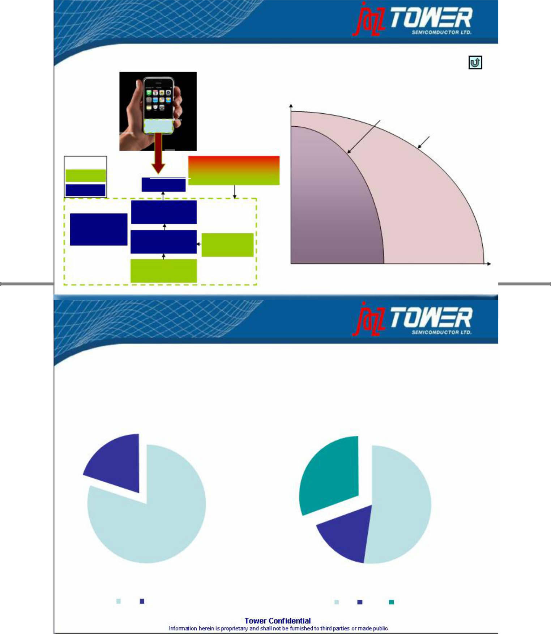

Goal: Replace Expensive Discrete GaAs Components with Single Silicon Chip

25

SiGe Market Overview

The SiGe market is estimated to total approx 2.0 million wafers per year and be worth approx $3.0 billion per year (analogous foundry wafer pricing)

Pure Play Foundry vs IDM Market Share Pure Play Market Share

20%

30%

53%

 | 80% | 17%
IDM Pure Play |  | IBM TSMC Jazz

Source: SemiCo 2006

26

The Specialty Foundry

AIMS & RF

(SiGe & RFCMOS)

Power Management

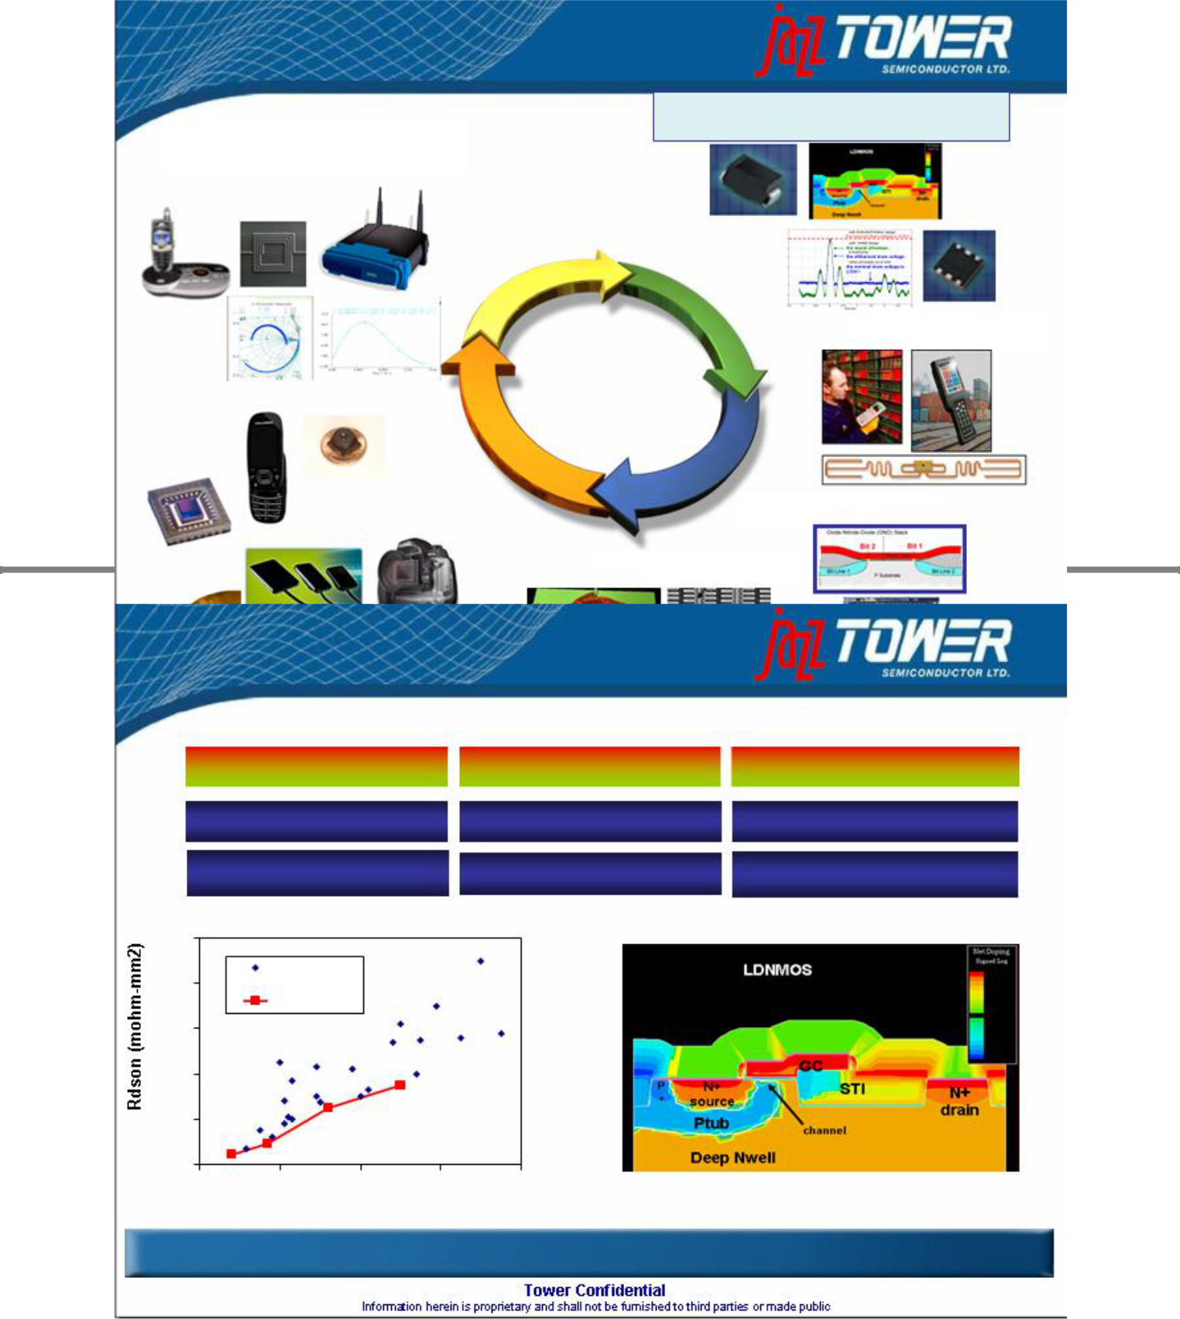
RFID

 | Specialty
 | Foundry
CMOS Image | eNVM
Sensors | eNVM
 | MEMS

27

Power Management Technology

0.5um | 0.25um | 0.18um
BCD05 (5/16Vgs, 40Vds) | CP05 (5V CMOS) | BCD18 (1.8/5Vgs, 40Vds)
TS05 (5Vgs, 40Vds) | BCD25 (5Vgs, 40Vds) | TS18SLPM (1.8/5Vgs, 42Vds)

100

Competition
80

Tower/Jazz
- Devices

40

20

0

0 | 20 | 40 | 60 | 80
 |  | BVdss

Best-in-Class On-Resistance Across Broad Range of Voltage and Geometry

28

Scalable LDMOS for Rdson/BVdss Optimization

Start

Add

Enable

Industry best LDMOS Model (NXP MM20)
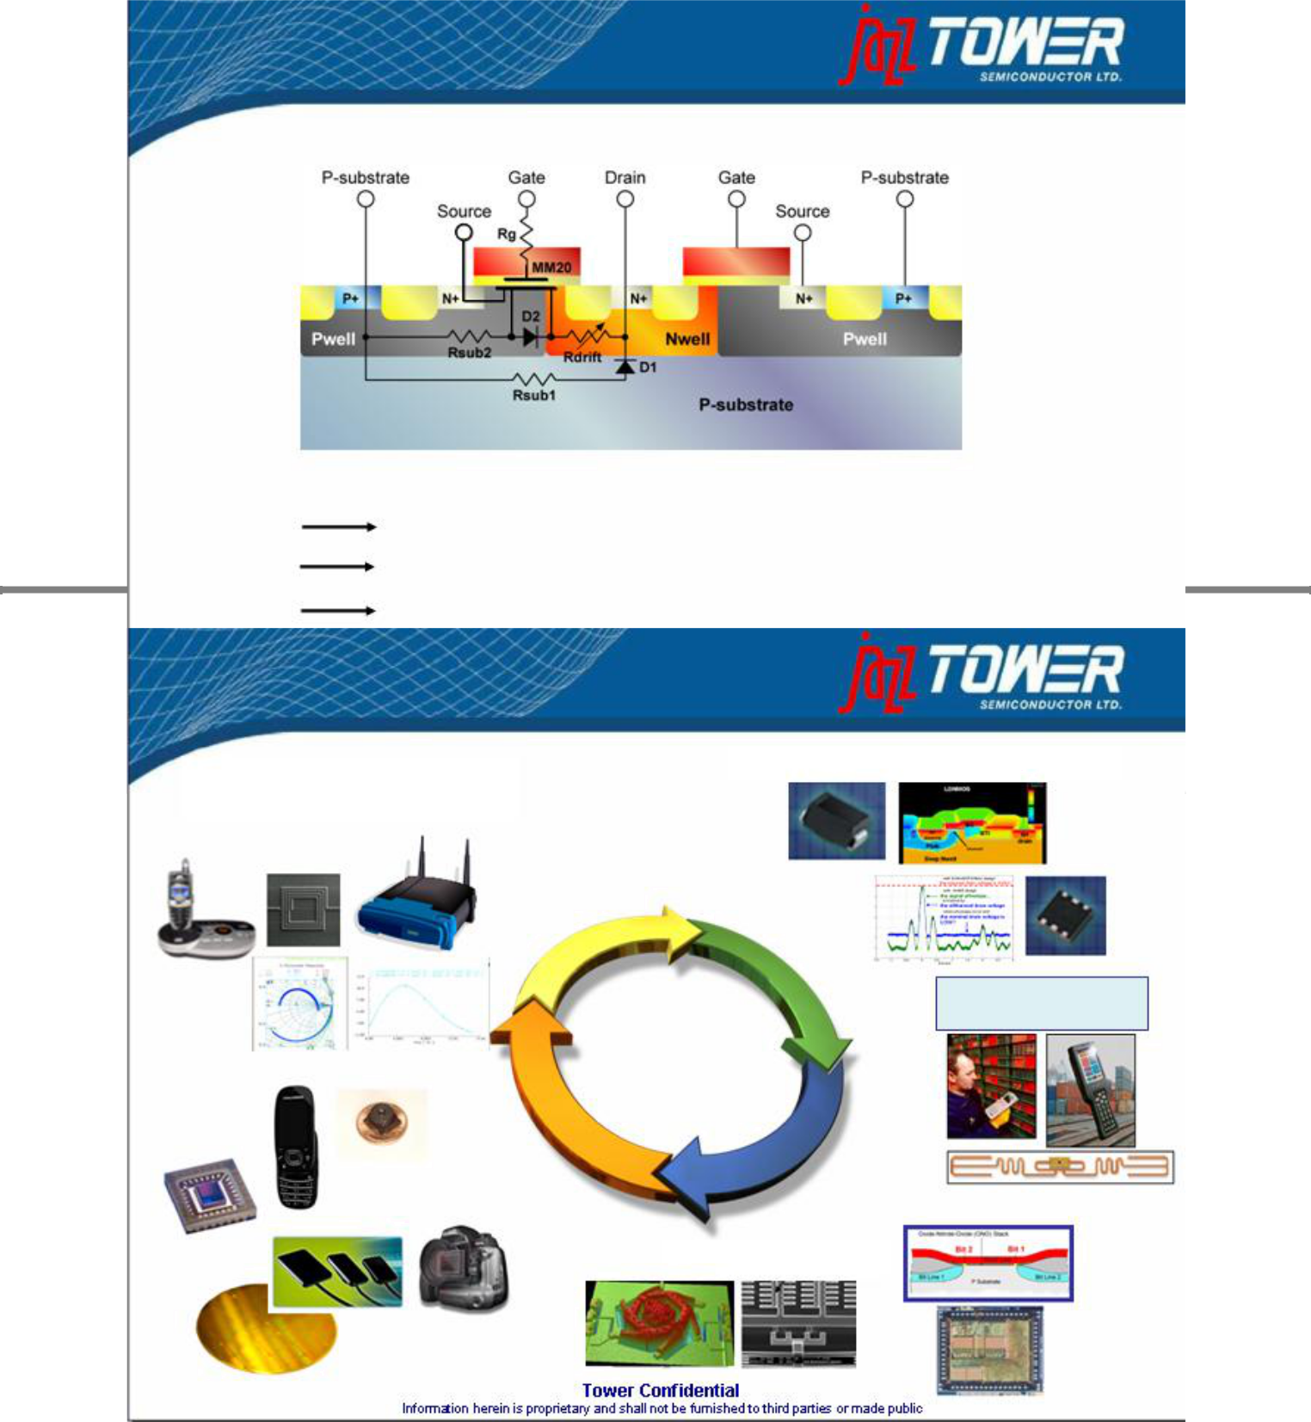

physical, scalable model for extended drift region

Rdson / BVdss optimization for each transistor in the design

Physical Model Makes Rdson / BVdss a Design Variable

29

The Specialty Foundry

AIMS & RF | Power Management
(SiGe & RFCMOS)

 | RFID
 | Specialty
 | Foundry
CMOS Image
Sensors | eNVM
 | MEMS

30

RFID – What is it ?

RFID = Radio Frequency IDentification An emerging new technology set out to replace bar-codes

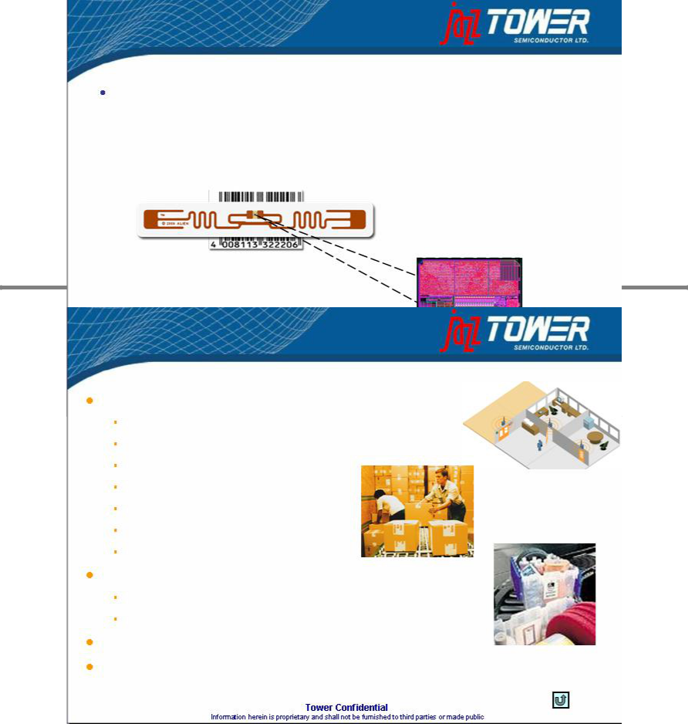

0.18u Ultra Low

Power RFID IC

31

RFID Offering @ Tower

Specialty process & device
Low cost 0.18µm 3LM Analog (DNW, MIM) process platform |  | Human
Schottky diodes – high speed low Von rectifiers
Native (“Zero Vt”) transistor | Postal
Extended voltage range | Postal
Specific Low Leakage (LL) devices
ESD solution (low RF-loss)
IP characterized for low Vdd operation
RFID NVM |  | Asset tracking
Low power MTP and OTP solutions (no added mask) |  | Asset tracking
Developed special low power NVM cells for RFID (CFlash)

Devices characterized over a wide frequency range

Support present systems (900MHz) and future needs (2.4GHz)

32

The Specialty Foundry

Power Management
AIMS & RF

(SiGe & RFCMOS)

RFID

 | Specialty
 | Foundry
CMOS Image | eNVM
Sensors | eNVM
 | MEMS
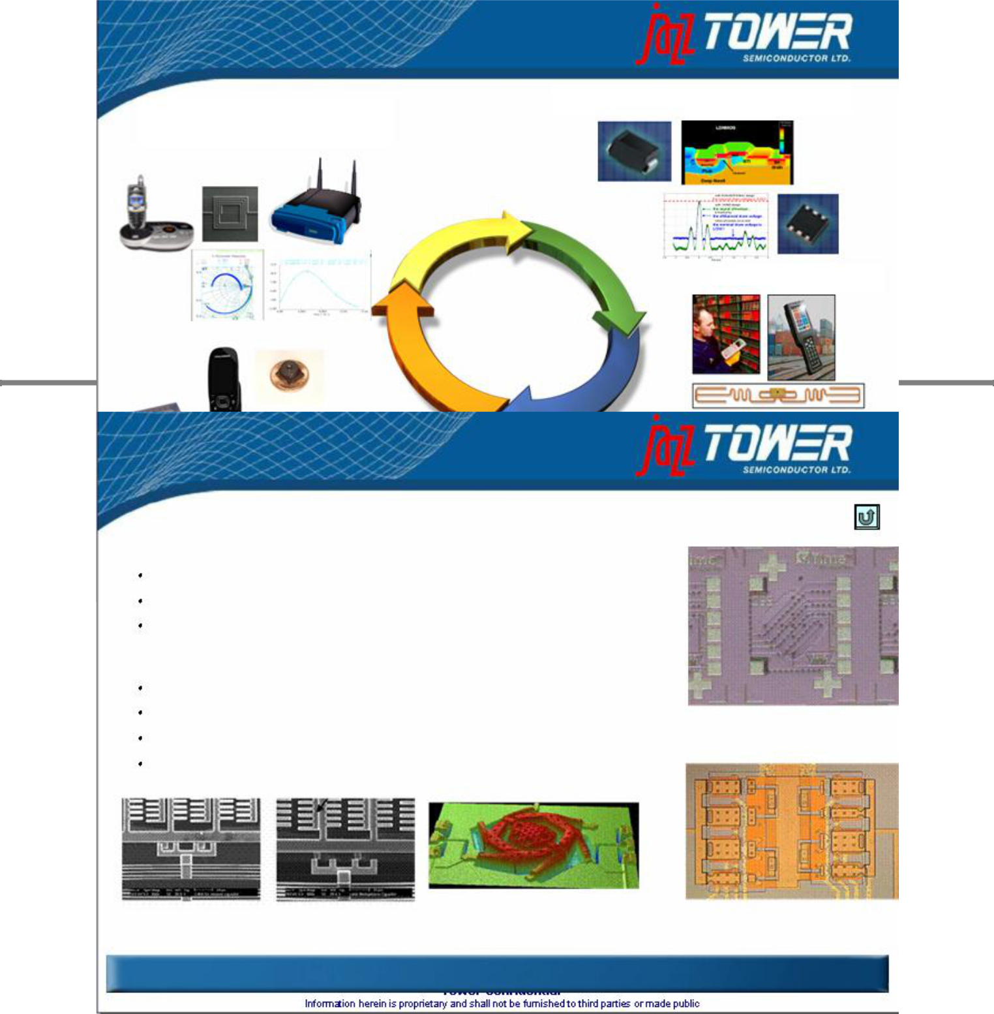

33

MEMS Technology and Services

Partnering with Customers for Volume MEMS Manufacturing

“Transfer–in” – Transfer existing process to Jazz for volume production “Co-develop” – Form joint program to deliver process & product “Develop to spec” – Jazz and partners build process & devices to spec

Examples

Si MEMS: Oscillator (replacing quartz oscillator)

RF MEMS: Tunable capacitor (for use in handsets)

Post Process MEMS: SBC35 + CMU Post Process MPW

Medical MEMS: In development

Si MEMS resonator – replaces quartz timing device. Courtesy SiTime

Tunable capacitor in VCO design | Interferometric image | Optical image of MEMS capacitor
courtesy Carnegie Mellon University | of Hex varactor | array for duplex or MIMO function

Partnering with Customers, University, DARPA to Bring MEMS to 200mm Si Wafer Manufacturing

34

The Specialty Foundry

Power Management
AIMS & RF

(SiGe & RFCMOS)

RFID

Specialty

Foundry
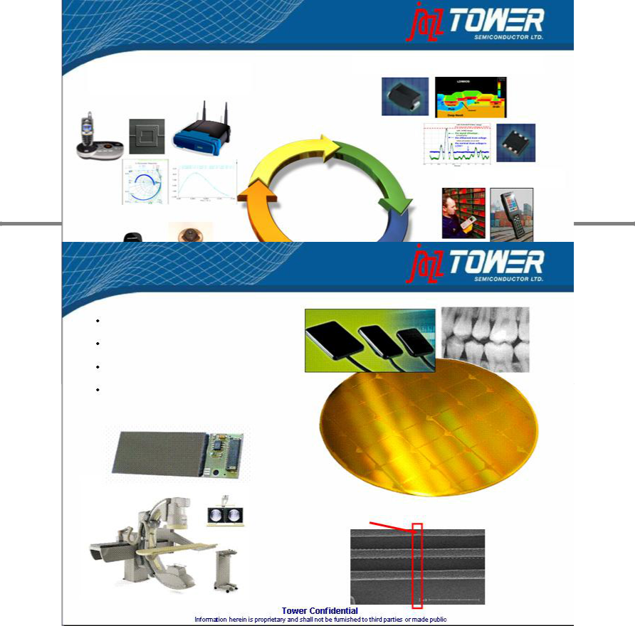

CMOS Image

Sensors

eNVM

MEMS

35

X-Ray market – Medical and Dental

Intra-Oral dental

Medical Imaging applications

Unique stitching technology

Silicon proven pixels

Seamless stitch boundary

0.28 micron stitched metal lines

36

Summary of Application Range

Industrial/ | Studio/High End Film
Machine Vision | Studio/High End Film
Machine Vision | Large Industrial/Scientific
Medical
Medical | Medical (X-ray)
 | Medical (X-ray) | 8” wafer size

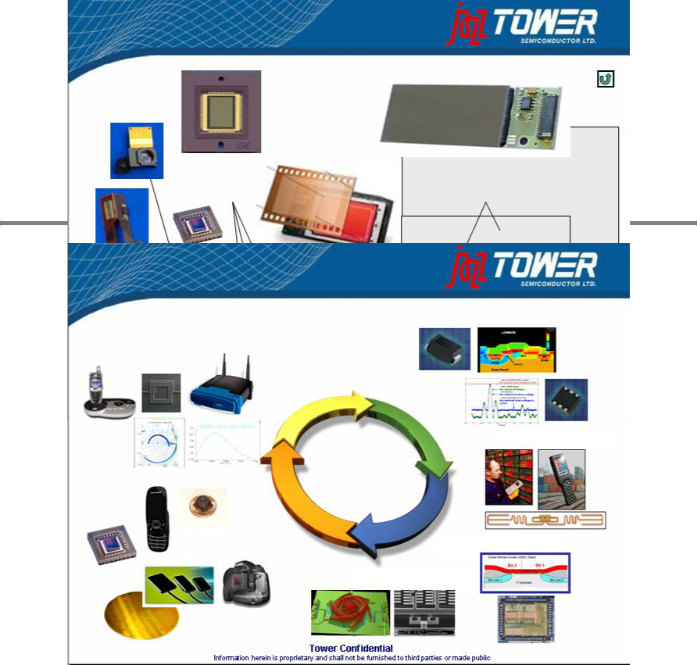
 | Advanced |  | Wafer Size
 | Advanced | Professional
 | Amateur | Professional
Consumer | Amateur | Film
Consumer | Film | Film
(CIF, VGA, SXGA, 2-3M) | Film
(CIF, VGA, SXGA, 2-3M) |  |  | 6” Wafer Size
Small Medical
1/10”1/3”_{1/2”} |  |  | 48x36
1/4”
2/3” ^{1”} | 4/3”APS (3:2) | 35 mm | 645

37

The Specialty Foundry

AIMS & RF

(SiGe & RFCMOS)

Power Management

RFID

 | Specialty
 | Foundry
CMOS Image | eNVM
Sensors | eNVM
 | MEMS

38

Jazz Target Markets

Radio Frequency | High Performance Analog
Cellular handset transceivers
WLAN / WiMAX transceivers |  | Optical networks
TV tuners |  | Data converters
GPS |  | Amplifiers, filters, mixers
Broadband

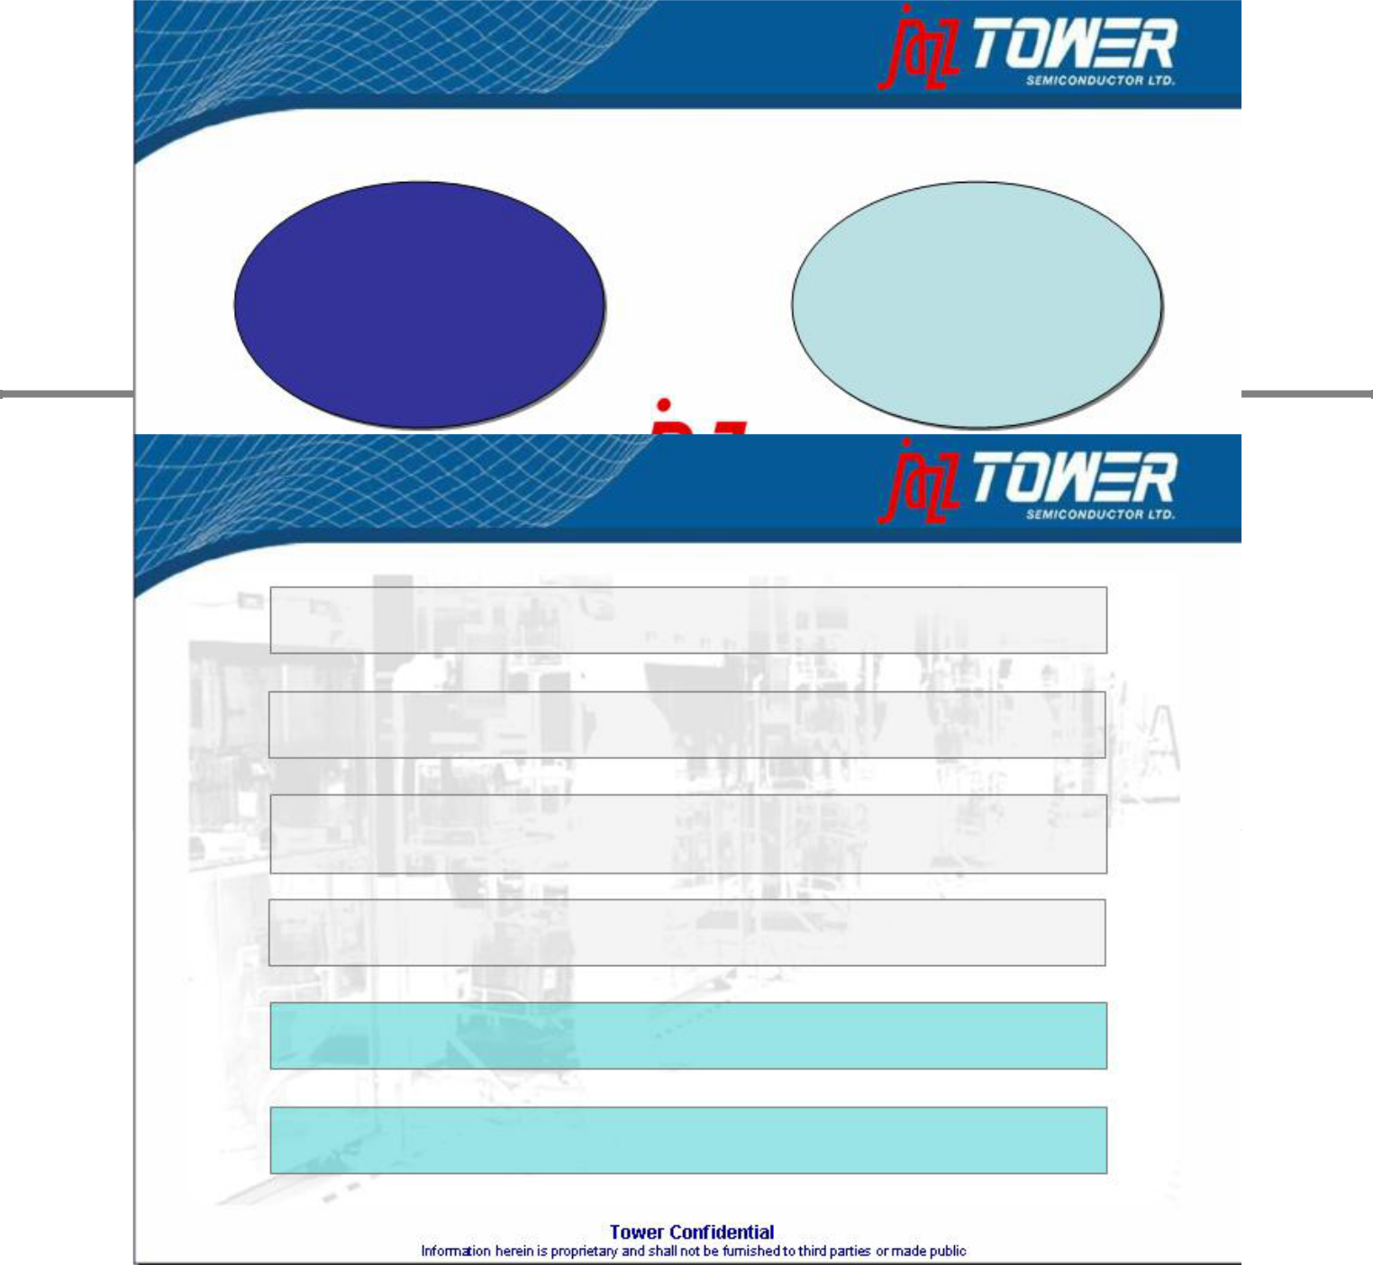
Power Management |  | Aerospace & Defense
LED Drivers |  |  | Infra-red night vision
Motor Control |  | Communications and radar

39

Creating the Leading Specialty Foundry

Increased Capacity and Scale to Attract Larger Customers

Global Presence Improves Geographic Reach and Distribution

Leadership In Specialty Process Technologies:

CMOS Image Sensor, SiGe, Power Mgmt, NVM, RF-CMOS, BCD

Synergies of Value Add Technologies Enables Higher Margins

Diverse Customer Base in High Growth Markets

Significant Synergy Potential Both on Revenues and Expenses

40

Foundry Revenue Growth Y/Y

 | 05vs04 |  | 06vs05 |  | 07vs06 |  | 07vs05
1 | Dongbu | 52% | Tower | 99% | X-Fab | 41% | Tower | 146%
2 | Others | 38% | Grace | 91% | CSMC Tech. | 36% | Grace | 114%
3 | SMIC | 20% | ASMC | 49% | Tower | 24% | X-Fab | 103%
4 | X-Fab | 14% | CSMC Tech. | 46% | Vanguard | 22% | CSMC Tech. | 99%
5 | He Jian | 9% | X-Fab | 44% | Silterra | 19% | Others | 55%
6 | SSMC | 8% | Chartered | 35% | Others | 17% | ASMC | 49%
7 | TSMC | 7% | Others | 32% | He Jian | 14% | Dongbu | 47%
8 | Chartered | 3% | Dongbu | 31% | Grace | 12% | Silterra | 42%
9 | Polar Semi. | -2% | SMIC | 25% | Dongbu | 12% | Vanguard | 37%
10 | CSMC Tech. | -3% | Silterra | 19% | Polar Semi. | 11% | SMIC | 33%
11 | HHNEC | -3% | TSMC | 19% | SSMC | 8% | He Jian | 32%
12 | ASMC | -9% | SSMC | 16% | Jazz | 8% | Chartered | 28%
13 | Jazz | -10% | He Jian | 16% | SMIC | 6% | SSMC | 25%
14 | Silterra | -13% | Vanguard | 13% | HHNEC | 6% | TSMC | 19%
15 | 1st Silicon | -15% | UMC | 13% | UMC | 2% | Polar Semi. | 17%

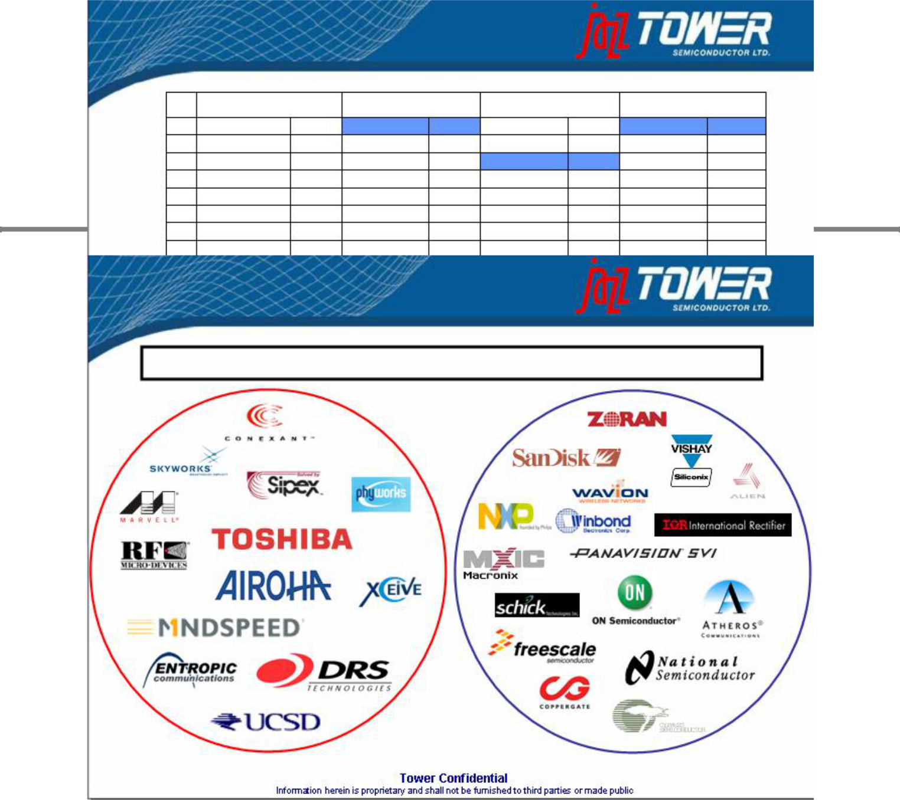
16 | UMC | -16% | Jazz | 7% | TSMC | 1% | Jazz | 16%
17 | Tower | -24% | Polar Semi. | 6% | Mosel-Vitelic | 1% | UMC | 15%
18 | Vanguard | -26% | HHNEC | 1% | ASMC | 0% | HHNEC | 7%
19 | Grace | -31% | 1st Silicon | NA | Chartered | -5% | Mosel-Vitelic | NA
20 | Mosel-Vitelic | NA | Mosel-Vitelic | NA | 1st Silicon | NA | 1st Silicon | NA

Source: The McLean Report, 2008 edition

41

Diverse Customer Base

No customer overlap out of the top 20 and only three out of the top 50

42

Combined Company Snapshot

Headquarters Migdal Haemek, Israel

Ticker TSEM (NASDAQ & Tel Aviv Stock Exchange)

Employees 1,950

Fabs Three fully owned (US and Israel), equity stake and partnership in

Chinese fabs - ~750,000 annual wafer capacity (8” equivalents)

Process SiGe/BiCMOS 0.35 to 0.13u
^{Technologies} Analog CMOS/RFCMOS/BCD 0.8 to 0.16u

CMOS Image Sensor 1.0u - 0.18u

CMOS 1.0u to 0.13u

IP Leadership AIMS (Analog Intensive Mixed Signal)

PDK (Physical Design Kits)

Embedded Flash MTP&OTP Solutions

Key Financial Highlights

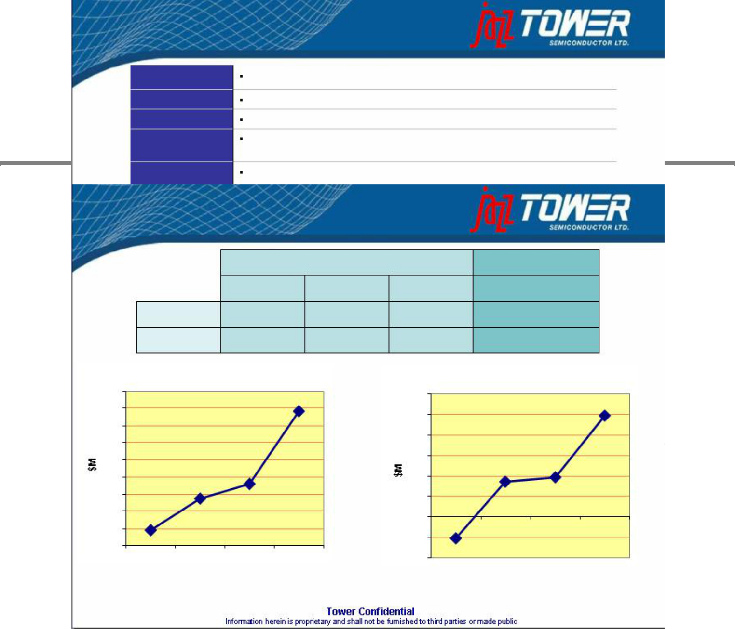
Combined trailing twelve months (TTM) revenues of $443 million
Impressive cash flow generation with $84 million of TTM EBITDA

Substantial, revenue and cost savings of up to $40 million annually Improved leverage ratios

43

Day-After Financials * ($M) :

Tower Tower & Jazz

2005 2006 2007 Q2’07-Q1’08

500

450

400

350

Sales | 94 | 187 | 231 | 443
EBITDA | (26) | 43 | 49 | 124

Sales EBITDA

150

125

100

300 |  |  |  | 75
250 |  |  |  | 50
200 |  |  |  | 25
150 |  |  |  | 0
100 |  |  |  | 2005 | 2006 | 2007 | Q2’07-Q1’08
50 |  |  |  | -25
2005 | 2006 | 2007 | Q2’07-Q1’08 | -50

* 2005 excludes $8M one-time effect from a Fab2 technology agreement

** LTM Ebitda assumes $40 million of synergies plan as announced on May 19, 2008

44

Combined Company Snapshot

Bottom line:

Tower Will “get”:

2X sales in Day1 post closing; targeting more than 2X within a year from customer synergies

2X-2.5X Ebitda from Day1 post closing; targeting much more than that within a year from customers & cost synergies

Tower will “pay” for that:

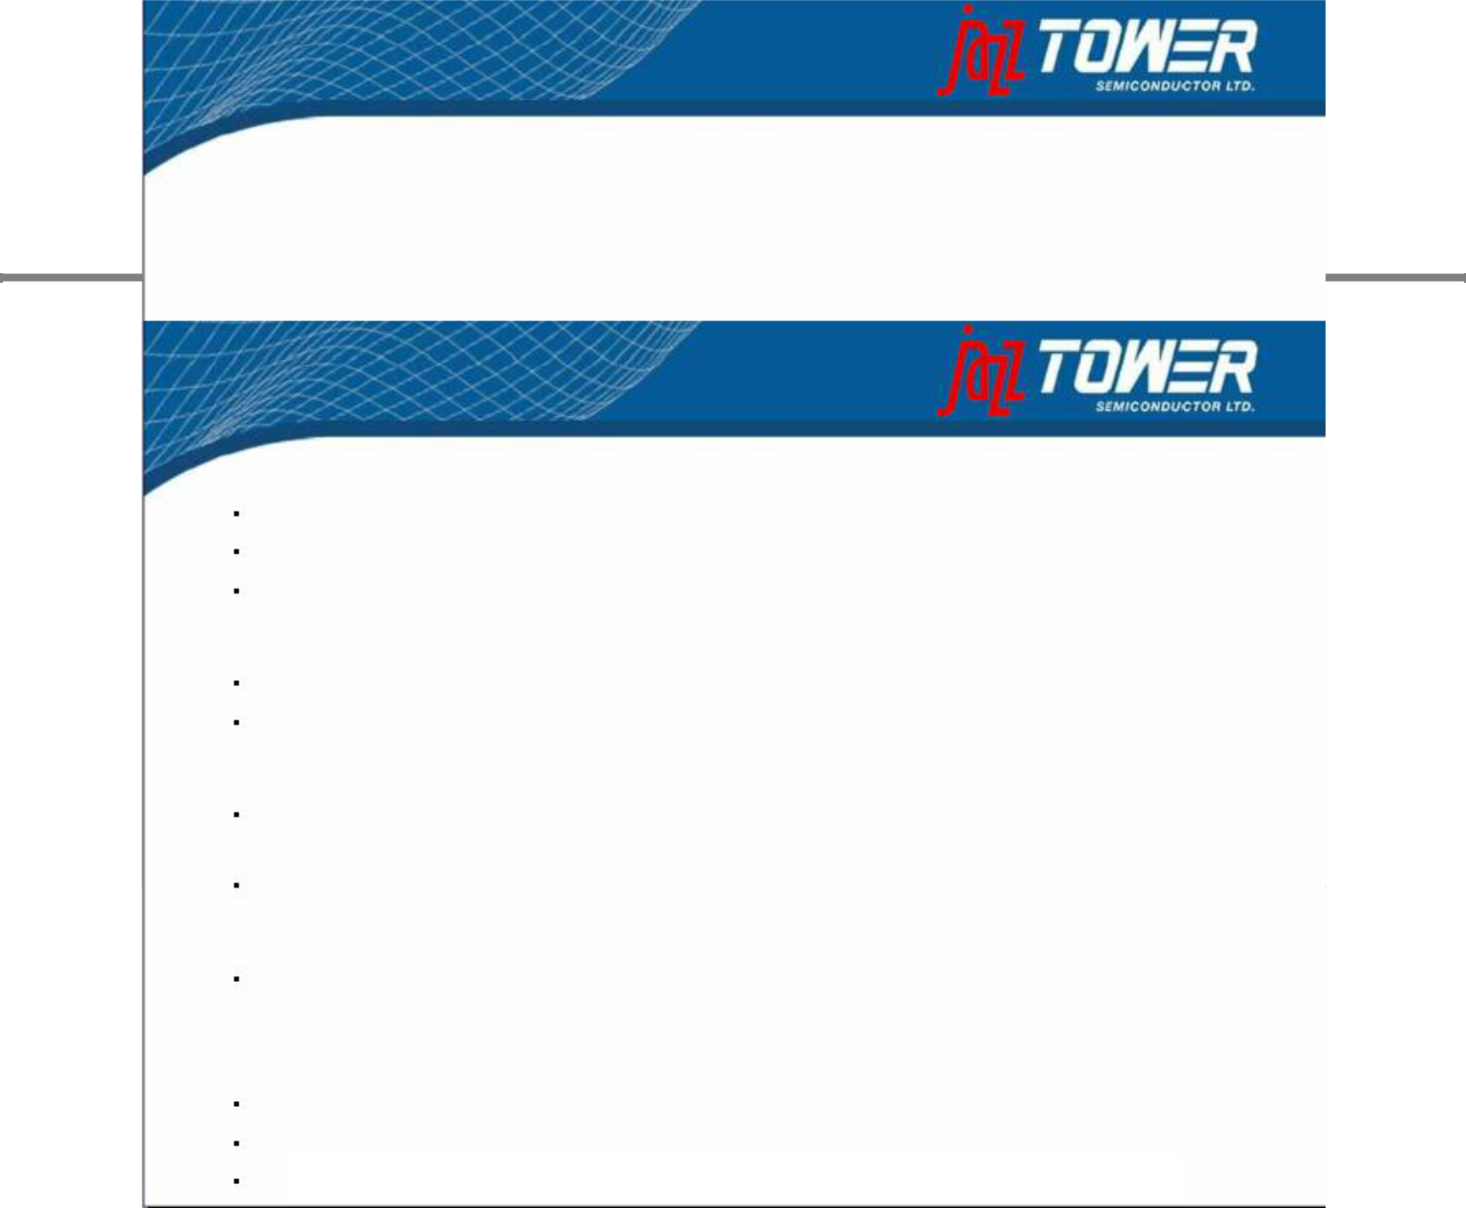
9% dilution (on a fully-diluted basis)

45

Summary Highlights

3rd Largest Pure Play Specialty Foundry

Increase capacity and scale to attract bigger customers

Capacity of ~750k wafer starts annually (8" equivalents)

Global manufacturing capacity and distribution network

Strong Sector Fundamentals

Pure play foundry revenues expected to grow by an average of 19% annually until 2012 Represents a growth rate of more than 50% higher than the total semi industry

Leadership in Specialty Process Technologies

Product offering ranges from CMOS Image Sensor, NVM and RF CMOS to specialty Mixed Signal, SiGe, Power Management and RF processes

Addition of value add technologies enable higher margins

Diversified Blue Chip Customer Base

SanDisk, Vishay Siliconix, On Semi, International Rectifier, Freescale, Toshiba, Texas Instruments, RFMD, Entropic

Exceptional Financial Performance and Significant Operating Leverage

10th successive quarters of positive EBITDA and Cash flow positive since Q4 ’06 Doubling of revenues and improved EBITDA margins through acquisition of Jazz

Potential synergies of approx $40 million resulting from Jazz transaction

46

Additional Information about the Proposed Merger

Additional Information about the Proposed Merger and Where to Find It -

In connection with the proposed merger, Tower has filed with the SEC a Registration Statement on Form F-4 (File No. 333-151919) (the "Form F-4") that contains a Proxy Statement/Prospectus and related materials and Jazz expects to mail to its stockholders the final Proxy Statement/Prospectus containing information about Tower, Jazz and the proposed merger. INVESTORS AND SECURITY HOLDERS ARE URGED TO READ THE PROXY STATEMENT/PROSPECTUS AND THE OTHER RELEVANT MATERIALS, CAREFULLY AND IN THEIR ENTIRETY, BECAUSE THEY CONTAIN IMPORTANT INFORMATION ABOUT TOWER, JAZZ AND THE PROPOSED MERGER. Investors and security holders may obtain free copies of the Form F-4, the Proxy Statement/Prospectus and other relevant materials and documents filed by Tower or Jazz with the SEC through the web site maintained by the SEC at www.sec.gov. In addition, investors and security holders may obtain free copies of the documents relating to the proposed merger filed with the SEC by Tower by directing a request by mail to Tower Semiconductor Ltd, P.O. BOX 619, Migdal Haemek, Israel 23105, Attn: Investor Relations or by telephone at +972-4-6506936. Investors and security holders may obtain free copies of the documents relating to the proposed merger filed with the SEC by Jazz by directing a request by mail to Jazz Technologies, Inc., 4321 Jamboree Road, Newport Beach, California 92660, Attn: Investor Relations or by telephone at +1 415 445-3236.

Tower, Jazz and their respective executive officers and directors, under SEC rules, may be deemed to be
participants in the solicitation of proxies from the stockholders of Jazz in connection with the proposed
merger. Investors and security holders may obtain information regarding the special interests of these executive
officers and directors in the proposed merger by reading the Proxy Statement/Prospectus filed with the SEC
when it becomes available. Additional information regarding Tower's executive officers and directors is included
in Tower's Form 20-F for the year ended December 31, 2007, which was filed with the SEC on June 18, 2008. Additional information regarding the executive officers and directors of Jazz is included in Jazz's Proxy Statement for its 2008 Annual Meeting of Stockholders, which was filed with the SEC on April 7, 2008. These

documents are available free of charge at the SEC's web site at www.sec.gov and are also available free of charge from Investor Relations at Tower and Jazz by contacting Tower and Jazz as described above.
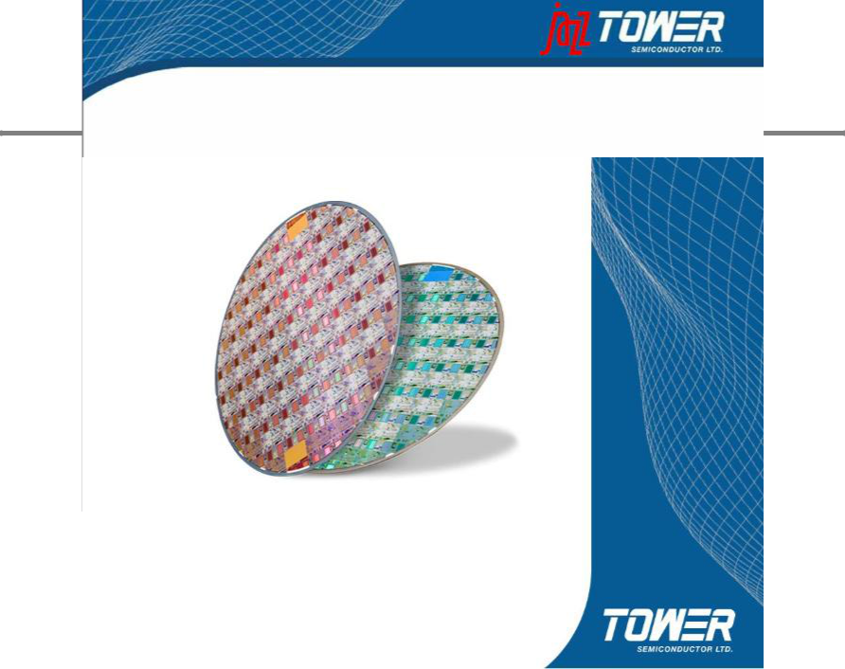

47

Thank You

48

About Tower Semiconductor Ltd.

Tower Semiconductor Ltd. is a pure-play independent specialty wafer foundry established in 1993. The company manufactures integrated circuits with geometries ranging from 1.0 to 0.13-micron; it also provides complementary technical services and design support. In addition to digital CMOS process technology, Tower offers advanced mixed-signal & RF-CMOS, Power Management, CMOS image-sensor and non-volatile memory technologies. To provide world-class customer service, the company maintains two manufacturing facilities, each with standard and specialized process technology processes: Fab 1 ranging from 1.0 to 0.35 and Fab 2 featuring 0.18 and 0.13-micron. Tower’s web site is located at http://www.towersemi.com.

Forward-Looking Statements

This document contains forward-looking statements within the meaning of the “safe harbor” provisions of the Private Securities Litigation Reform Act of 1995, including statements concerning Tower’s proposed merger with Jazz. These statements are based on management’s current expectations and beliefs and are subject to a number of risks, uncertainties and assumptions that could cause actual results to differ materially from those described in the forward-looking statements. All statements other than statements of historical fact are statements that could be deemed forward-looking statements. For example, statements of expected synergies, customer benefits, costs savings, financial guidance, the timing of closing, industry ranking, execution of integration plans and management and organizational structure are all forward-looking statements. The potential risks and uncertainties include, among others, the possibility that the merger does not close or that the closing may be delayed, that expected customer benefits, synergies and costs savings will not be achieved or that the companies are unable to successfully execute their integration strategies, that the companies may be required to modify the terms of the transaction to achieve regulatory approval or for other reasons, that prior to or after the closing of the merger, the businesses of the companies may suffer due to uncertainty, as well as other risks applicable to both Tower’s and Jazz’s business described in the reports filed by Tower and Jazz with the Securities and Exchange Commission (the “SEC”) and, in the case of Tower, the Israel Securities Authority. These filings identify and address other important factors that could cause Tower’s and Jazz’s respective financial and operational results to differ materially from those contained in the forward-looking statements set forth in this document. Accordingly, no assurances can be given that any of the events anticipated by the forward-looking statements will transpire or occur, or if any of them do so, what impact they will have on the results of operations or financial condition of Tower or Jazz. Tower and Jazz are providing this information as of the date of this document and neither Tower nor Jazz undertakes any obligation to update any forward-looking statements contained in this document as a result of new information, future events or otherwise.

49

A more complete discussion of risks and uncertainties that may affect the accuracy of forward-looking statements included in this press release or which may otherwise affect Tower’s business is included under the heading “Risk Factors” in Tower’s most recent filings on Forms 20-F, F-3 and 6-K, as were filed with the SEC and the Israel

Securities Authority. Future results may differ materially from those previously reported. Tower does not intend to update, and expressly disclaims any obligation to update, the information contained in this document.

Additional Information about the Proposed Merger and Where to Find It

In connection with the proposed merger, Tower has filed with the SEC a Registration Statement on Form F-4 (File No. 333-151919) (the “Form F-4”) that contains a Proxy Statement/Prospectus and related materials and Jazz expects to mail to its stockholders the final Proxy Statement/Prospectus containing information about Tower, Jazz and the proposed merger. INVESTORS AND SECURITY HOLDERS ARE URGED TO READ THE PROXY STATEMENT/PROSPECTUS AND THE OTHER RELEVANT MATERIALS, CAREFULLY AND IN THEIR ENTIRETY, BECAUSE THEY CONTAIN IMPORTANT INFORMATION ABOUT TOWER, JAZZ AND THE PROPOSED MERGER. Investors and security holders may obtain free copies of the Form F-4, the Proxy Statement/Prospectus and other relevant materials and documents filed by Tower or Jazz with the SEC through the web site maintained by the SEC at www.sec.gov. In addition, investors and security holders may obtain free copies of the documents relating to the proposed merger filed with the SEC by Tower by directing a request by mail to Tower Semiconductor Ltd, P.O. BOX 619, Migdal Haemek, Israel 23105, Attn: Investor Relations or by telephone at +972-4-6506936. Investors and security holders may obtain free copies of the documents relating to the proposed merger filed with the SEC by Jazz by directing a request by mail to Jazz Technologies, Inc., 4321 Jamboree Road, Newport Beach, California 92660, Attn: Investor Relations or by telephone at +1 415 445-3236.

Tower, Jazz and their respective executive officers and directors, under SEC rules, may be deemed to be participants in the solicitation of proxies from the stockholders of Jazz in connection with the proposed merger. Investors and security holders may obtain information regarding the special interests of these executive officers and directors in the proposed merger by reading the Proxy Statement/Prospectus filed with the SEC when it becomes available. Additional information regarding Tower’s executive officers and directors is included in Tower’s Form 20-F for the year ended December 31, 2007, which was filed with the SEC on June 18, 2008. Additional information regarding the executive officers and directors of Jazz is included in Jazz’s Proxy Statement for its 2008 Annual Meeting of Stockholders, which was filed with the SEC on April 7, 2008. These documents are available free of charge at the SEC’s web site at www.sec.gov and are also available free of charge from Investor Relations at Tower and Jazz by contacting Tower and Jazz as described above.

50

