FORM 6-K

SECURITIES AND EXCHANGE COMMISSION

Washington, D.C. 20549

For the month October 2024 No. 1

TOWER SEMICONDUCTOR LTD.
(Translation of registrant's name into English)

Ramat Gavriel Industrial Park
P.O. Box 619, Migdal Haemek, Israel 2310502
(Address of principal executive offices)

Indicate by check mark whether the registrant files or will file annual reports under cover Form 20-F or Form 40-F.

Form 20-F ☒ Form 40-F ☐

Indicate by check mark whether the registrant by furnishing the information contained in this Form is also thereby furnishing the information to the Commission pursuant to Rule 12g3-2(b) under the Securities Exchange Act of 1934.

Yes ☐ No ☒

On October 21, 2024, the Registrant Announces Third Quarter
2024 Financial Results and Conference Call

SIGNATURES

Pursuant to the requirements of the Securities Exchange Act of 1934, the registrant has duly caused this report to be signed on its behalf by the undersigned, thereunto duly authorized.

 | TOWER SEMICONDUCTOR LTD.
Date: October 21, 2024 | By: | /s/ Nati Somekh
 |  | Name: Nati Somekh
 |  | Title: Corporate Secretary

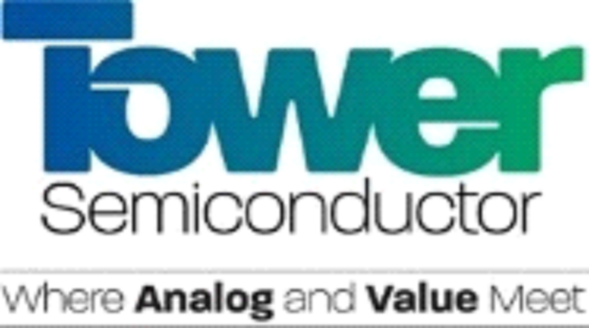

Tower Semiconductor Announces Third Quarter 2024 Financial
Results and Conference Call

MIGDAL HAEMEK, Israel – October 21, 2024 – Tower Semiconductor (NASDAQ/ TASE: TSEM), the leading foundry of high value analog semiconductor solutions, will issue its third quarter 2024 earnings release on Wednesday, November 13, 2024. The Company will hold a conference call to discuss its third quarter 2024 financial results and fourth quarter 2024 guidance on Wednesday, November 13, 2024, at 10:00 a.m. Eastern Time (09:00 a.m. Central, 08:00 a.m. Mountain, 07:00 a.m. Pacific and 05:00 p.m. Israel time).

The call will be webcast and available through the Investor Relations section of Tower Semiconductor’s website at https://ir.towersemi.com/, where the pre-registration form required for dial-in participation is also accessible. Upon completing the registration, participants will receive the dial-in details, a unique PIN, and a confirmation email with all necessary information. The teleconference will be available for replay for 90 days.

About Tower Semiconductor
Tower Semiconductor Ltd. (NASDAQ/TASE: TSEM), the leading foundry of high-value analog semiconductor solutions, provides technology, development, and process platforms for its customers in growing markets such as consumer, industrial, automotive, mobile, infrastructure, medical and aerospace and defense. Tower Semiconductor focuses on creating a positive and sustainable impact on the world through long-term partnerships and its advanced and innovative analog technology offering, comprised of a broad range of customizable process platforms such as SiGe, BiCMOS, mixed-signal/CMOS, RF CMOS, CMOS image sensor, non-imaging sensors, displays, integrated power management (BCD and 700V), photonics, and MEMS. Tower Semiconductor also provides world-class design enablement for a quick and accurate design cycle as well as process transfer services including development, transfer, and optimization, to IDMs and fabless companies. To provide multi-fab sourcing and extended capacity for its customers, Tower Semiconductor owns two facilities in Israel (150mm and 200mm), two in the U.S. (200mm), two in Japan (200mm and 300mm) which it owns through its 51% holdings in TPSCo, shares a 300mm facility in Agrate, Italy, with ST as well as has access to a 300mm capacity corridor in Intel’s New Mexico factory. For more information, please visit: www.towersemi.com.

###

Contact Information:
Tower Semiconductor Investor Relations
Noit Levy, SVP Investor Relations
noitle@towersemi.com | +972-74-7377556

