FORM 6-K

SECURITIES AND EXCHANGE COMMISSION

Washington, D.C. 20549

For the month July 2025 No. 3

TOWER SEMICONDUCTOR LTD.
(Translation of registrant's name into English)

Ramat Gavriel Industrial Park
P.O. Box 619, Migdal Haemek, Israel 2310502
(Address of principal executive offices)

Indicate by check mark whether the registrant files or will file annual reports under cover Form 20-F or Form 40-F.

Form 20-F ☒ Form 40-F ☐

Indicate by check mark whether the registrant by furnishing the information contained in this Form is also thereby furnishing the information to the Commission pursuant to Rule 12g3-2(b) under the Securities Exchange Act of 1934.

Yes ☐ No ☒

On July 30, 2025, the Registrant Announces Receipt of Best
Supplier Award from Wisol for Excellence in RF SOI Technology
and Supply Chain Support

SIGNATURES

Pursuant to the requirements of the Securities Exchange Act of 1934, the registrant has duly caused this report to be signed on its behalf by the undersigned, thereunto duly authorized.

 | TOWER SEMICONDUCTOR LTD.
Date: July 30, 2025 | By: | /s/ Nati Somekh
 |  | Name: Nati Somekh
 |  | Title: Corporate Secretary

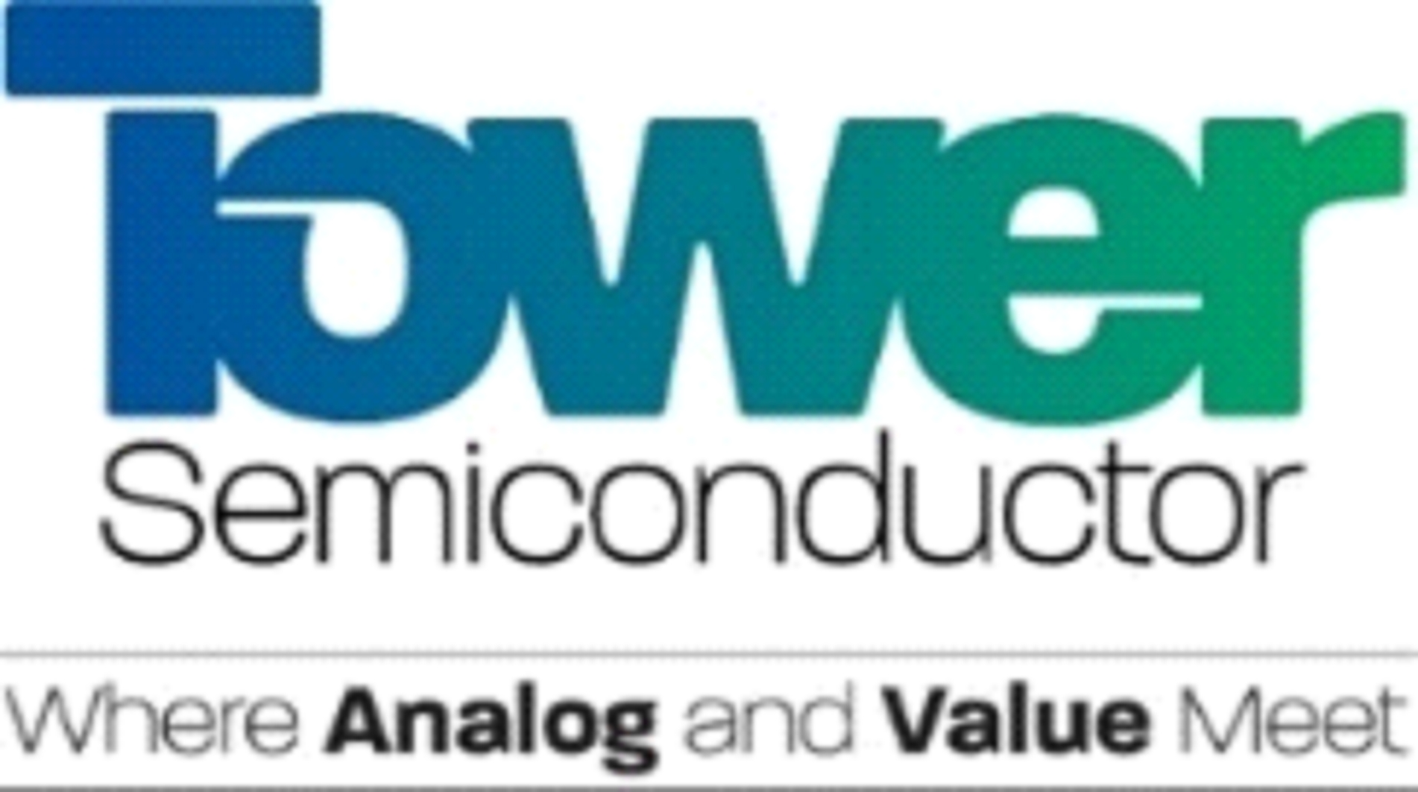

Tower Semiconductor Receives Best Supplier Award from Wisol for Excellence in RF SOI Technology
and Supply Chain Support

MIGDAL HAEMEK, Israel, — July 30, 2025 - Tower Semiconductor, a leading foundry of high-value analog semiconductor solutions, announced today that it has been awarded the Best Supplier Award by Wisol, a key vendor of RF filters and modules used by global top-tier mobile phone manufacturers. Wisol supplies RF front-end module (FEM) devices based on Tower’s advanced 300mm RF SOI technology, produced at Tower’s facilities in Uozu, Japan and Agrate, Italy.

The award recognizes Tower’s long-standing partnership with top-tier vendors and its unwavering commitment to stable and timely delivery, technological excellence, and responsive engineering support. It also reinforces Tower’s position as a trusted global foundry partner, helping customers succeed in competitive markets.
JiHo Kim, Wisol CEO stated, “Tower Semiconductor has continuously provided outstanding process technology, dependable on-time delivery, and agile engineering support, enabling us to meet our customer’s high standards for performance and reliability. Their RF SOI platform plays a crucial role in the competitiveness of our next-generation RF modules.”

Tower’s 300mm RF SOI platform has been a critical enabler for the development and high-volume production of high-performance RF front-end ICs required in mobile phones. With key features such as low insertion loss, high linearity, and superior integration, the platform is widely adopted across the mobile, IoT, and automotive markets, addressing the industry’s growing need for compact, power-efficient, and high-performance RF solutions.
Through close collaboration with Wisol from initial design enablement to mass production, Tower has supported the demanding delivery schedules of Wisol to its customers including global leaders such as Samsung Electronics and other OEMs, while providing flexible, reliable, and efficient technical support that has enabled Wisol to meet stringent performance requirements.

“We are deeply honored to receive this recognition from Wisol, a long-term and highly valued partner,” said Dr. Marco Racanelli, President, Tower Semiconductor. “This award reflects our commitment to delivering technological excellence and customer-centric manufacturing solutions that empower our partners to lead in dynamic and highly competitive sectors.”

For additional information about the Company’s RF platform offering, visit here.

About Tower Semiconductor
Tower Semiconductor Ltd. (NASDAQ/TASE: TSEM), the leading foundry of high-value analog semiconductor solutions, provides technology, development, and process platforms for its customers in growing markets such as consumer, industrial, automotive, mobile, infrastructure, medical and aerospace and defense. Tower Semiconductor focuses on creating a positive and sustainable impact on the world through long-term partnerships and its advanced and innovative analog technology offering, comprised of a broad range of customizable process platforms such as SiGe, BiCMOS, mixed-signal/CMOS, RF CMOS, CMOS image sensor, non-imaging sensors, displays, integrated power management (BCD and 700V), photonics, and MEMS. Tower Semiconductor also provides world-class design enablement for a quick and accurate design cycle as well as process transfer services including development, transfer, and optimization, to IDMs and fabless companies. To provide multi-fab sourcing and extended capacity for its customers, Tower Semiconductor owns one operating facility in Israel (200mm), two in the U.S. (200mm), two in Japan (200mm and 300mm) which it owns through its 51% holdings in TPSCo, shares a 300mm facility in Agrate, Italy with STMicroelectronics as well as has access to a 300mm capacity corridor in Intel’s New Mexico factory. For more information, please visit: www.towersemi.com.

Safe Harbor Regarding Forward-Looking Statements
This press release includes forward-looking statements, which are subject to risks and uncertainties. Actual results may vary from those projected or implied by such forward-looking statements. A complete discussion of risks and uncertainties that may affect the accuracy of forward-looking statements included in this press release or which may otherwise affect Tower’s business is included under the heading “Risk Factors” in Tower’s most recent filings on Forms 20-F, F-3, F-4 and 6-K, as were filed with the Securities and Exchange Commission (the “SEC”) and the Israel Securities Authority. Tower does not intend to update, and expressly disclaim any obligation to update, the information contained in this release.

###

Tower Semiconductor Company Contact: Orit Shahar | +972-74-7377440 | oritsha@towersemi.com

Tower Semiconductor Investor Relations Contact: Liat Avraham | +972-4-6506154 | liatavra@towersemi.com

