UNITED STATES

SECURITIES AND EXCHANGE COMMISSION

Washington, D.C. 20549

FORM 6-K

REPORT OF FOREIGN PRIVATE ISSUER PURSUANT TO RULE 13a-16 OR 15d-16

OF THE SECURITIES EXCHANGE ACT OF 1934

For the month of June 2026 No.3

Commission File Number 000-24790

TOWER SEMICONDUCTOR LTD.

(Translation of registrant's name into English)

Ramat Gavriel Industrial Park

P.O. Box 619, Migdal Haemek, Israel 2310502

(Address of principal executive offices)

Indicate by check mark whether the registrant files or will file annual reports under cover of Form 20-F or Form 40-F.

Form 20-F ☒ Form 40-F ☐

Tower Semiconductor Ltd. (“Tower”) issued a letter to shareholders on June 22, 2026 (the “Letter to Shareholders”), which contains supplemental information to the proxy statement for its Annual General Meeting of Shareholders to be held on July 2, 2026 that was attached as Exhibit 99.1 to the Report of Foreign Private Issuer on Form 6-K furnished by Tower to the U.S. Securities and Exchange Commission (“SEC”) on May 21, 2026. A copy of the Letter to Shareholders is furnished herewith as Exhibit 99.1 to this Report of Foreign Issuer on Form 6-K.

Exhibit 99.1 Tower Semiconductor Ltd. Letter to Shareholders Issued on June 22, 2026

SIGNATURES

Pursuant to the requirements of the Securities Exchange Act of 1934, the registrant has duly caused this report to be signed on its behalf by the undersigned, thereunto duly authorized.

 | TOWER SEMICONDUCTOR LTD.
Date: June 22, 2026 | By: | /s/ Nati Somekh
 | Name: | Nati Somekh
 | Title: | Corporate Secretary

Exhibit 99.1

Dear Shareholders,

We are writing to provide supplemental information to the proxy statement of Tower Semiconductor Ltd. (“we”, “us”, “our”, the “Company”, or “Tower”) for Tower’s Annual General Meeting of Shareholders to be held on July 2, 2026, that was attached as Exhibit 99.1 to the Report of Foreign Private Issuer on Form 6-K furnished by Tower to the U.S. Securities and Exchange Commission, the Israel Securities Authority and the TASE, on May 21, 2026 (the “Proxy Statement”). This letter supplements the information in the Proxy Statement regarding Proposal 3, which seeks approval of an amended and restated compensation policy for Tower’s directors and executive officers.

Why We Recommend a Vote FOR Proposal 3

Tower’s Board of Directors recommends that shareholders vote FOR Proposal 3, approval of the amended and restated compensation policy.

In accordance with Israeli law applicable to Israeli public companies, the compensation policy must be approved at least once every three by the Compensation Committee, the Board of Directors and by the shareholders by the required majority. The compensation policy should be designed to promote a company’s goals, work plan and policy from a long term perspective and create appropriate incentives for the company's officers and directors, taking into account, among other things, the company's risk management policy.

Given the significant positive changes in our business trajectory since the adoption of the existing compensation policy, together with our strategic plans for the next three years, the proposed amended compensation policy is designed to support this growth, and reflect Tower’s anticipated business development, company ambitions and competitive landscape, while maintaining the responsible and balanced approach that has consistently guided our compensation practices. The proposed amendments are intended to ensure that Tower can continue attracting, retaining and motivating the leadership talent necessary to support Tower’s continued growth and long-term shareholder value creation, as evidenced by the approximately $28 billion increase in the market capitalization of Tower over the past year (from June 15, 2025 to June 15, 2026).

Please see Appendix A to this letter for a summary of the proposed changes in the amended compensation policy and the related business rationale and governance safeguards specific to each proposed modification. Please also see Appendix D to this letter for the full text of the proposed amended and restated Compensation Policy, which has been marked to highlight the proposed amendments.

Tower Has Changed Significantly Since the Existing Compensation Policy Was Approved

When Tower's existing compensation policy was approved in 2023, the Company was significantly smaller than it is today. Since that time, Tower's business has strengthened significantly and its market capitalization has increased approximately seven-fold, driven by strong execution and leadership of the management team, expanding customer demand, growth in AI, data center and radio frequency infrastructure markets, and the increasing strategic importance of Tower's specialty semiconductor technologies. As a result, Tower now competes with a different group of companies for executive talent than it did in 2023.

The Board believes the Company's compensation framework should evolve alongside the Company's size, complexity and competitive positioning.

These changes are exemplified by our strong stock price performance, which exceeded the total shareholder return of the iShares Semiconductor ETF (SOXX) by more than 137% from January 1, 2025 to June 15, 2026 (see Appendix C to this letter).

Tower Competes Globally for Executive Talent

Tower operates on a global scale and competes globally for executive talent, particularly against U.S.-based semiconductor and other high-technology companies. 42% of our 2025 revenue came from the U.S., which was our largest reported geographic region by revenue. The Company must be able to recruit and retain leaders with deep expertise in semiconductor manufacturing, technology development, operations, customer engagement and global business management.

In addition, many members of Tower's senior executive team have long tenures with the Company. Tower’s CEO and the six direct reports to the CEO have an average tenure of 27 years, ranging from 21 to 34 years with Tower. As Tower plans for the future, it is important to maintain flexibility to support succession planning and leadership transitions when they occur. The proposed modifications to the existing compensation policy are intended to ensure that Tower may continue to attract highly qualified executives capable of sustaining the Company's long-term success.

Executive Compensation Benchmarking

Our primary compensation benchmarking source is a 17-company peer group of U.S.-based semiconductor and other high-tech hardware companies (see Appendix B to this letter). Tower’s $1.62 billion trailing four quarter revenue ended March 31, 2026 is at the 41st percentile of the peer group’s trailing four quarters, and its $32 billion market capitalization on June 15, 2026 was approximately 2x the peer group median market capitalization of $16 billion, underscoring that the Company has outgrown the compensation framework established when it was materially smaller.

The Compensation Committee also reviewed key provisions from the compensation policies of the eight largest Israeli companies (based on 2025 average market capitalization, which relates to their latest compensation year) that file proxy statements under Israeli governance rules and are also listed on a U.S. stock exchange, as summarized by our independent compensation consultant, FW Cook.

As described in greater detail in the Proxy Statement, when the proposed maximum value of annual CEO equity compensation of 13 times the CEO’s annual salary is converted to a percentage of market capitalization to standardize comparison to the market data, it is lower than the median of the CEO equity awards in our primary U.S.-based peer group, and is also lower than the median CEO equity compensation limit among the secondary sample of Israeli companies (included in Exhibit C to the Proxy Statement).

The Proposed Amended Compensation Policy Supports Competitive Performance Based Compensation, Not Automatic Compensation

Proposal 3 does not approve any specific future payment to directors or executive officers, hiring decisions or equity grants. Rather, it establishes the framework within which the Compensation Committee and Board may operate over the next three years, as required by Israeli law. The purpose of a compensation policy is to put caps on executive officers’ and directors’ compensation and it is not a guarantee of future compensation.

Any future decisions regarding director and executive officer compensation will continue to be evaluated based on market data, Company strategy and performance, individual performance, and will be subject to approval of the requisite corporate bodies under applicable Israeli law at the time of determination.

Strong Shareholder Protections Remain in Place

The Board continues to maintain strong governance protections under the proposed amended compensation policy while conducting its periodic executive compensation review:

- The majority of executive long-term incentive compensation continues to be performance-based.

- Total dilution for shares subject to outstanding equity awards remains capped at 10% of fully diluted shares outstanding.

- CEO and director equity awards continue to be subject to shareholder approval.

- Executive and director stock ownership guidelines remain in place and compliance is enforced.

- Clawback provisions and requirements remain in effect.

Why the Board Believes that Approval of Proposal 3 Is in Shareholders' Best Interests

Failing to update the compensation framework to reflect the Company’s current competitive position could limit Tower's ability to recruit, retain and motivate the leadership talent necessary to execute its strategy in an increasingly competitive global semiconductor market.

The proposed amendments are designed to address Tower’s significantly increased scale, complexity and market capitalization to enable Tower's continued growth, and to preserve meaningful shareholder protections, all while maintaining a strong pay-for-performance philosophy.

For these reasons, the Board of Directors unanimously recommends that shareholders vote:

FOR Proposal 3 — Approval of the Amended and Restated Compensation Policy

If you have already cast a vote contrary to the Board of Directors recommendation on Proposal 3 and wish to change your vote, you may change your vote by following the instructions under the heading “Change or Revocation of Proxy” in the Proxy Statement.

Thank you for your continued support.

The supplemental information included in this letter should be read together with the Proxy Statement. Except as specifically supplemented by the information contained in this letter, all information set forth in the Proxy Statement remains accurate and should be considered when voting your shares. The Proxy Statement was furnished to the U.S. Securities and Exchange Commission as Exhibit 99.1 to the Report of Foreign Private Issuer Form 6-K on May 21, 2026 and is available on its website at www.sec.gov, and was also filed with the Israel Securities Authority and the TASE and is available on their websites at www.magna.isa.gov.il and maya.tase.co.il, respectively.

Forward-Looking Statements

This letter includes certain “forward-looking” statements within the meaning of Section 21E of the Securities Exchange Act of 1934, as amended. There can be no assurance that actual results will not differ materially from our expectations or projections. Factors that could cause actual results to differ from our expectations or projections include the risks and uncertainties relating to our business described in “Item 3. Key Information-D. Risk Factors” of our Annual Report on Form 20-F for the year ended December 31, 2025, filed with the Commission on April 30, 2026.

Sincerely,

On behalf of the Board of Directors

Amir Elstein

Chairman of the Board of Directors

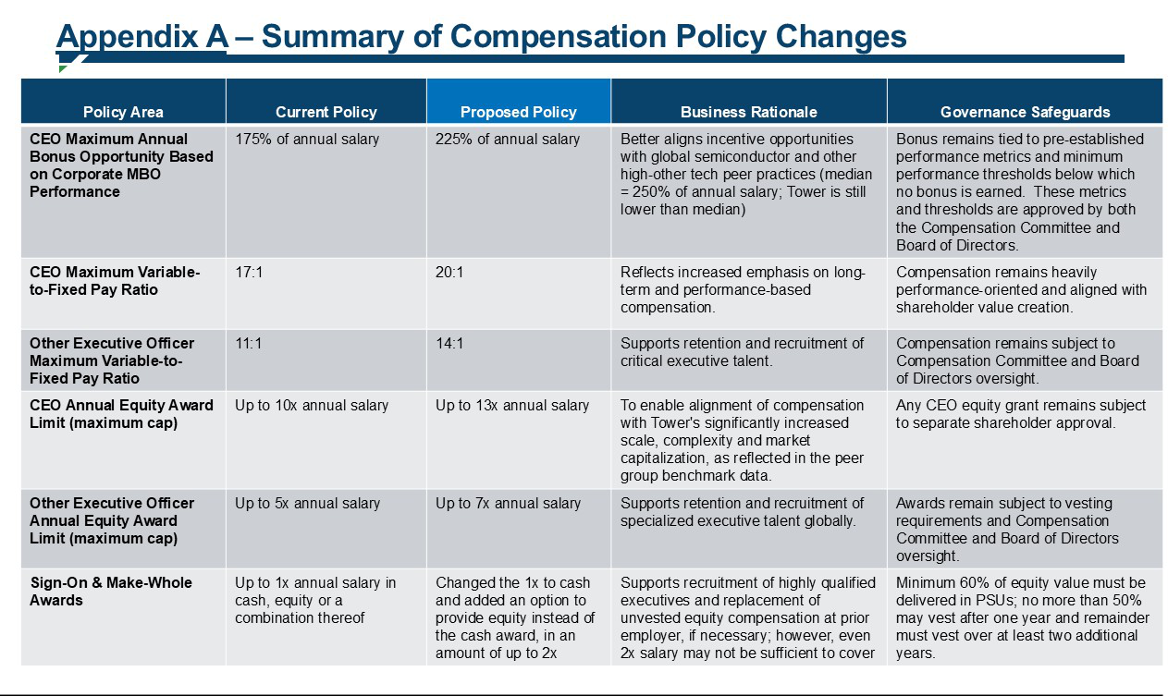

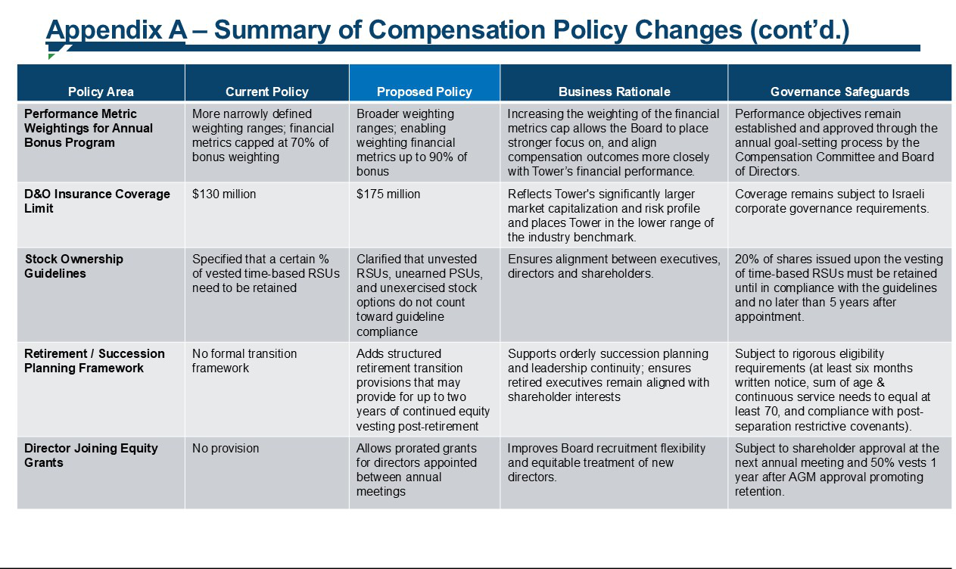

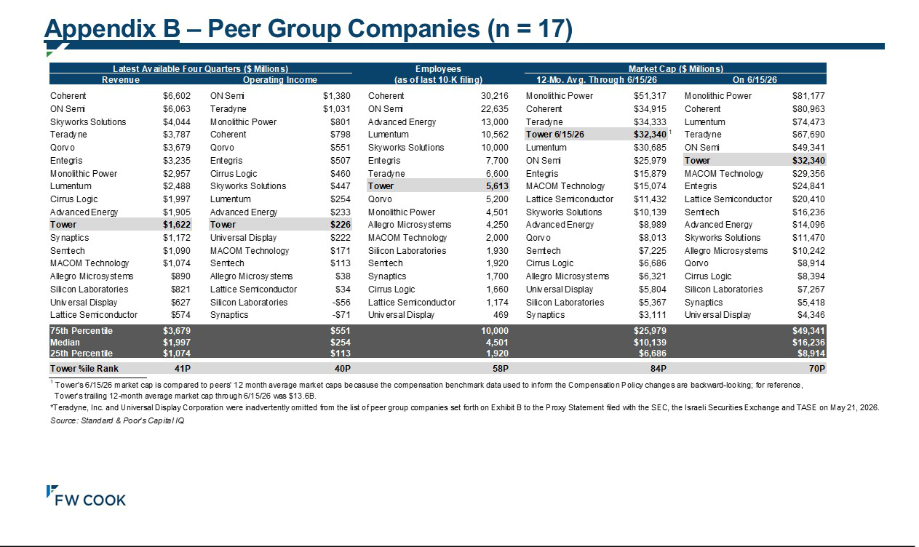

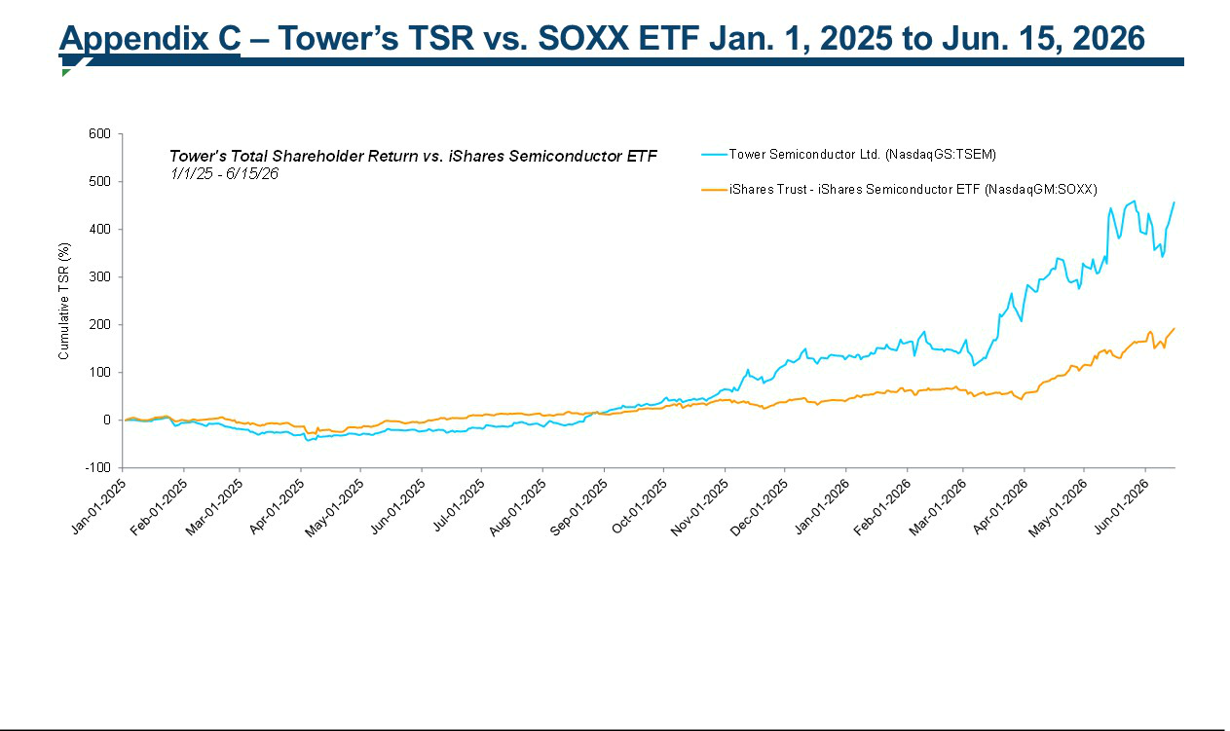

COMPENSATION POLICY

TOWER SEMICONDUCTOR LTD.

Compensation Policy for Executive Officers and Directors

A. Overview and Objectives

- Introduction

This document sets forth the compensation policy for Executive Officers and Directors (both as defined herein) of Tower Semiconductor Ltd. ("Tower" or the "Company"), in accordance with the requirements of the Companies Law (this "Compensation Policy" or "Policy").

Compensation is a key component of Tower’s overall human capital strategy to attract, retain, reward, and motivate highly skilled individuals who will enhance Tower's value and otherwise assist Tower to reach its business and financial long term goals. The Policy is designed to provide the Compensation Committee and Board of Directors the tools and mechanisms to incentivize the Executive Officers and promote the Company’s growth plans. Accordingly, the structure of this Policy is established to tie the compensation for each Executive Officer to Tower's goals and performance.

This Compensation Policy will be in effect for a period of three (3) years from the date the Policy is duly approved under the Companies Law.

The Compensation Committee and the Board of Directors of Tower shall review and reassess the adequacy of this Policy from time to time, as required by the Companies Law.

In setting the compensation of the Executive Officers and Directors, the Compensation Committee and the Board of Directors shall consider, among other things, the following factors:

- the educational, professional experience and accomplishments of the Executive Officer or Director;

- the Executive Officer or Director's position, responsibilities and prior compensation arrangements;

- compensation data for comparably situated executives at peer companies, including companies in the industry and/or geographic market;

- data of other senior executives of the Company;

- macroeconomic environment;

- Company's own performance;

- the Executive Officer or Director's expected contribution to the Company’s future growth and profitability;

- the relationship between the compensation paid to the Executive Officer or Director and the average and median compensation of the Company’s employees and contractors, as well as whether such variation has an effect on employment relations; and

- any requirements prescribed by applicable law from time to time.

- Objectives

Tower’s objectives and goals in setting this Compensation Policy are to maintain competitiveness by attracting, motivating and retaining highly talented and experienced personnel with the necessary capabilities to promote creativity and manage global operations. These abilities are critical to Tower's long-term success in order to provide leadership, and enhance shareholder value, while supporting a performance culture that is based on merit, motivates individuals to perform at their highest level, differentiates and rewards excellent performance, and recognizes Tower's values. Due to Tower's unique position as an Israeli company with a global footprint, it aims to adopt compensation policies and procedures that match global companies of similar complexity, including semiconductor companies and other companies which compete with Tower for similar talent, and companies in the relevant geographical location, while complying with applicable local laws and customs as well. Executive Officers’ or Directors’ total compensation may deviate from target level where required to attract or retain individuals or reflect their respective characteristics or performance.

To that end, this Policy is designed, among others:

2.1. To closely align the interests of the Executive Officers and Directors with those of Tower’s shareholders in order to enhance shareholder value;

2.2. To provide the Executive Officers and Directors with a structured compensation package, including competitive salaries and performance-based cash and equity incentive programs;

2.3. To maintain and increase the level of motivation and ambition and promote for each an opportunity to advance in a growing organization and strive for excellence;

2.4. To provide appropriate awards for superior individual and corporate performance;

2.5. To improve the business results and increase income and profitability over time; and

2.6. To support the implementation of the Company's business strategy.

- Compensation structure and instruments

Compensation instruments under this Compensation Policy may include the following:

3.1. Base salary;

3.2. Benefits and perquisites;

3.3. Performance-based cash bonuses;

3.4. Equity based compensation; and

3.5. Retirement, termination and other arrangements.

- Ratio between variable and fixed compensation

4.1.This Policy aims to optimize the mix of Fixed Compensation and Variable Compensation (both as defined herein) in order to, among other things, appropriately incentivize Executive Officers to meet Tower's goals while considering Tower's management of business risks.

4.2.As a rule, the total of the Variable Compensation to be given to an Executive Officer over a calendar year relative to the Fixed Compensation shall not exceed the “Executive Ratio” which shall be 1720 for the CEO and 114 for Other Executive Officers. The Executive Ratio is calculated based on the following assumptions: (i) maximal possible payments that may be made to Executive Officers under the Variable Compensation covered by this Policy (bonuses and equity); (ii) any CEO relocation related reimbursement expenses included under Fixed Compensation and assuming no relocation expenses for any Other Executive Officer; and

  - excluding any potential sign-on bonuses for new hires. The variable component in regard of the equity compensation reflects the annual amortization over the vesting period.

- Inter-Company Compensation Ratio

In the process of composing this Policy, the possible ramifications of the Employee Ratio on the work environment in Tower were examined in order to ensure that levels of executive compensation, as compared to the overall workforce, will not have a negative impact on work relations in Tower.

B. Base Salary, Benefits and Perquisites

- Base Salary

6.1.The base salary varies between Executive Officers, and is individually determined according to the past performance, educational background, place of residence, prior business experience, qualifications, specializations, situation, role, business responsibilities and achievements of the Executive Officer and the previous salary arrangements therewith.

6.2.Since a competitive base salary is essential to Tower's ability to attract and retain highly skilled professionals, Tower will seek to establish and maintain base salaries that are based on competitive market analyses. The comparative peer group will include direct competitors, or companies that operate in similar industries, with similar market capitalization, enterprise value, and/or revenues, active in similar geographic locations.

- Benefits and Perquisites

7.1. Executive Officers will be entitled to benefits stated as such by relevant law and best practice for peer companies.

7.2. Executive Officers may also be entitled to additional benefits, taking into consideration their rank, seniority in the territory they reside in, market and local practice and legislation. Such additional benefits, which shall be subject to approval of the Compensation Committee and the Board of Directors, may include, inter alia, annual vacation, sick leave, medical insurance, allocations to pensions, long term disability, contribution to an education fund (up to the maximum allowable by law), car expenses, contribution to managers' insurance, cellular phone and laptop computer, as well as taxes and expenses which may be incurred in relation to such benefits being borne by the Company.

7.3. In addition, when relevant, and subject to approval of the Compensation Committee and the Board of Directors, Executive Officers may be entitled to relocation related expenses and benefits until termination, including housing costs, family flights and related repatriation costs, which shall not exceed $280,000 on an annual basis.

C. Sign-on Awards and Cash Bonuses

- Sign-on Bonus

8.1. For purposes of attracting high quality personnel, Tower may offer an Executive Officer a sign-on bonus as an incentive to join the Company.

8.2. The sign-on bonus may be comprised of either (i) cash and/or equity andthat shall not exceed a grossn amount equal to the Executive's Officer's annual gross base salary; or (ii) . Any equity based compensation to be granted as part of a sign-on bonus with an aggregate value of up to 2 annual gross base salaries. This grant may also include a make-whole award to replace forfeited equity compensation at a new-hire executive’s previous emplo yer, which may be needed from time to time to enable hiring experienced, quality talent, consistent with market practice. Any equity granted under this section 8.2, shall consist of RSUs and PSUs with a minimum of 60% of the award value being in PSUs, and shall vest as follows: not more than 50% of such grant shall vest on the first anniversary from date of grant, and the remaining 50% or more may vest over a minimum of two years from the first anniversary of the date of grant (i.e., at least three year vesting in total). Such grants will be subject to the same Change in Control provisions as are applicable to the Company’s other equity awards granted to Executive Officers. Equity awards under this section 8.2 are not subject to the terms and limitations of either Section 4, 14 or 18 due to their one-time, case-by-case nature.

8.3. The sign-on cash bonus, if one is provided, will be paid half on signing the employment contract and half will be paid on the second anniversary from the signing date, subject to continued employment with Tower during said two year period. In the event the employee resigns or is terminated for cause before the end of said two (2) year period, the first half of said cash bonus may be clawed back and repaid to the Company.

- Annual Bonus - The Objective, Components and Threshold

9.1.Compensation in the form of cash bonus(es) is an important element in aligning Executive Officers' compensation with Tower's objectives and business goals in the long-term, such that both individual performance and overall company success are rewarded.

9.2.Tower's policy is to allow annual cash bonuses, which may be awarded to the Executive Officers upon the attainment of pre-set annual measurable objectives and personal performance, which are set in the first quarter of the year, and include minimum thresholds for performance, as well as individual and/or division/department performance goals and personal development goals for Other Executive Officers.

9.3.A pre-defined mechanism will include bonus criteria based on the following components, with the weight (in percentage terms) of each group of measures as a portion of the annual criteria as set out below:

A = Corporate MBO Score (as defined herein) that is calculated in any year based on Tower financial/operational/strategic measures (subject to bonus threshold criteria), such as the criteria specified below, which score can range from 0 to 1.5. Each measure has 3 points: threshold, base and maximum.

Financials metrics: 340-790%, including categories such as:

– Revenue

– EBITDA

– Cash balance

– Net profit

– Specific annual balance sheet cap-table related metrics, focused on increasing shareholders' value, such as balance sheet ratios, refinancing, restructurings. Business - Strategic & tactical : 150-50%, including categories such as:

– Existing customers and revenue funnel which is the base for the following years' revenue growth

– Business Units major strategic programs

– Specific M&A targets

– Annual specific major tactical customer driven activities

– Customer support, including categories such as top customers scorecards feedback Operations: 10-40%, including categories such as:

– Cost

– On time delivery

– Quality

– Other measurable manufacturing indices

– Safety

– Annually specific activities (such as capacity increase) HR: 50-15%, including categories such as:

– Employee turnover

– Talent programs' success

– Employees' satisfaction

B = score granted to the Executive Officer after an evaluation of his/her individual performance, considering the position of the Executive Officer and the contribution of the Executive Officer to the achievement of the Company's targets. The B score will result in a bonus (not subject to the bonus threshold) as described below.

9.4. General bonus threshold –if the Corporate MBO Score is less than the applicable score set forth in Section 10 below, no bonus will be granted for the “A” component of the Corporate MBO Score in such year.

- The Formula

10.1. The annual bonus will be based on the measurable objectives of the Company as described above. Such measurable criteria will be determined for each fiscal year as a function of the annual operating plan that is approved by the Board of Directors before the end of the first quarter of each year, and will include financial, operational and strategic measures, on the basis of the balance between long term and short term considerations.

10.2. The annual bonus of the CEO will be calculated using the below formula:

CEO monthly actual base salary x [A + B] = Total Payout

For the "A" component applicable to this Section 10.2, after meeting the minimum threshold which enables a bonus, multiple sections (financial/operational/strategic measures) will have individual weights and criteria, with the weight (in percentage terms) of each measure as a portion of the annual criteria, such that the total "A" component of the bonus shall be set at 7.5 months, 15 months and 2127 months of the CEO’s monthly base salary for "A" scores of 0.7, 1.0 and 1.3, respectively. Between each two of the abovementioned scores, the "A" component shall be calculated linearly based on the Corporate MBO Score. The maximum bonus amount under the "A" component is capped at 21 months of the CEO's monthly base salary for any "A" score of 1.3 or above.

For the "B" component, a bonus with an annual cap of 3 monthly base salaries may be granted according to the chairman of the board of director's recommendation in regard to an evaluation of the CEO's individual performance, and subject to Compensation Committee and Board of Directors approval.

The minimum threshold for the entitlement of the CEO to receive the bonus under the "A" component is a weighted average Corporate MBO Score of 0.7. The Board of Directors may define additional threshold(s) at its discretion. The entitlement for the "B" component of the cash bonus has no minimal threshold.

10.3. The annual bonuses of Other Executive Officers will not exceed the Executive Maximum Amount, subject to the Executive Ratio described in 4.2 above.

10.4. The minimum threshold for the entitlement of the Other Executive Officers to receive the bonus under the "A" component is a weighted average Corporate MBO Score of 0.65. The Board of Directors may define additional threshold(s) at its discretion. The entitlement for the "B" component of the cash bonus has no minimal threshold. Achievement of the individual and/or division/department performance goals and personal development goals of the Other Executive Officers may have a minimum threshold according to the CEO’s discretion.

10.5. The Compensation Committee and Board intend to review, discuss and approve management recommendation for the specific Corporate MBO objectives which recommendation shall be made in the first quarter of each fiscal year with respect to such year, and which if met shall entitle the Executive Officers to an annual bonus for his/her performance in such year. Notwithstanding the foregoing, the CEO shall be entitled to determine and approve the annual measurable objectives, individual and/or division/department performance goals and personal development goals for the Other Executive Officers, which if met shall entitle the Other Executive Officers to an annual bonus for his/her performance in such year, in which case the CEO shall update and report to the Compensation Committee on such objectives and goals of the Other Executive Officers so established.

11. Special bonus for special achievements

11.1. Executive Officers may receive a special bonus for substantial achievements on special transactions that are unexpected when determining the Company's annual MBO plan as defined below, following recommendation and approval of the Compensation Committee and Board. It is clarified that this special bonus mechanism will not be awarded as a matter of routine and granted only in situations where it is warranted as described below.

Special transactions shall include M&A Transactions (defined below) with financial or strategic parties as well as transactions in which third parties enter into binding agreements pursuant to which they undertake to invest in the Company or its subsidiaries, new business models/joint development projects, customer financed large technology and new technology entrance, equity or debt financing, restructure the Company's debt or which include a “take or pay” commitment or which transaction includes a “pre-payment” basis.

11.2. Such special bonus shall not exceed the amount of four (4) monthly salaries of each applicable Executive Officer and the entitlement for this bonus has no minimal threshold condition.

- Compensation Recovery ("Clawback")

12.1.In the event that an Executive Officer was paid any compensation based on erroneous data which is later restated in the Company’s financial statements within a period of three (3) financial years prior to the date of the correction, the Company shall be entitled to recover from such Executive Officer any compensation in the amount of the excess of the compensation that the Executive Officer received over what he/she should have been paid on the basis of the restated financial statements.

12.2.Notwithstanding the aforesaid, the compensation recovery will not be triggered in the event of a financial restatement required due to changes in the applicable financial reporting standards.

12.3. The Compensation Committee will be responsible for approving the amounts to be recouped and for setting terms for such recoupment from time to time.

12.4. In addition, the Company has adopted an incentive compensation claw-back policy in accordance with rules of the U.S. Securities and Exchange Commission and Nasdaq Stock Market.

D. Equity Based Compensation

- The Objective

13.1.The equity based compensation for Tower's Executive Officers and Directors is designed in a manner consistent with the underlying Policy objectives in determining the base salary and the annual cash bonus, with its main objectives being to enhance the alignment between the Executive Officers' and Directors’ interests with the long term interests of Tower and its shareholders, and to strengthen the retention and the motivation of Executive Officers and Directors in the long term. In addition, since equity based awards are to be structured to vest over several years, their incentive value to recipients is aligned with longer-term strategic plans.

13.2.The equity based compensation offered by Tower is intended to be in a form of stock options, restricted stock units (RSUs), performance based stock units (PSUs) and/or other equity forms, in accordance with the Company’s equity based compensation policies and programs in place from time to time.

13.3. Total outstanding equity based compensation awarded by the Company at any time shall not be in excess of 10% of the Company’s share capital on a fully diluted basis.

14. General guidelines for the grant of equity based awards

14.1. The equity based compensation, comprised of options and/or RSUs and PSUs, shall be granted as either an annual grant and/or from time to time be individually determined and awarded according to the performance,

educational background, prior business experience, qualifications, specializations, role, personal responsibilities and achievements of the Executive Officer and the previous salary arrangements therewith.

14.2. As a general policy, options for Tower's Executive Officers shall gradually vest per passage of time over a period of 3 years (or more) and the RSUs shall have time and/or performance based vesting. There shall be no vesting before the end of the first year from date of grant.

14.3. The CEO may be granted equity, more than half of which shall be PSUs, annually at a value calculated based on the Equity Calculation Model which shall not exceed ten 13thirteen annual base salaries. Each Other Executive Officer may be granted equity, more than half of which shall be PSUs, annually at a value calculated based on the Equity Calculation Model which shall not exceed five seven annual base salaries of such Other Executive Officer. In addition, the Executive Officers may be granted, on an annual basis, additional PSUs that will vest subject to and only in the event that the Company’s actual performance exceeds the corporate annual plan and/or pre-defined performance target(s) required to be met for the vesting of the initial PSUs awarded to the applicable executive officer for such period, in a value that shall be pre-determined by the Compensation Committee and Board of Directors, provided that the maximum value of any such additional PSUs shall not exceed 100% of the value of the initial PSUs awarded to the applicable Executive Officer for such period. The terms of any such PSUs shall be in compliance with the terms of this Policy and the applicable Company equity-based incentive plan.

14.4. Since the Company strives and targets growth to enhance shareholders’ value and special leadership is required for successful execution, additional performance based equity awards at a value calculated based on the Equity Calculation Model, which shall not exceed 6 annual base salaries may be provided to the CEO and 4 annual base salaries may be provided to Other Executive Officers subject to the achievement of one or more long term goals, such as special operational, strategic, financial or business goal(s) that are challenging to attain within a five year period and are beyond the Company’s current ongoing activities, to be predetermined by the Compensation Committee and Board of Directors. For such awards, the Compensation Committee will provide the rationale for the use thereof in its recommendation to the Board of Directors for approval. This additional grant shall fully vest upon achievement of the defined long-term goal(s) or partially vest upon the achievement of pre-defined milestones and a minimum vesting period and may be granted only if no other such grant is outstanding. In addition, in the event of a “Change of Control” event resulting in an Executive Officer’s “Termination Upon Change of Control,” both terms as defined in the Executive Officer’s employment agreement or terms of employment, the performance-based equity awards under this section for which the performance target(s) have been met as of the date of the Executive Officer’s employment termination will be fully accelerated. Any performance-based equity awards under this section for which the performance target(s) have not been met as of the date of “Termination Upon Change of Control” would terminate immediately upon such termination of employment. .

14.5. The exercise price of options granted to the Executive Officers and Directors shall be equal to the arithmetic average closing price of Tower's shares, as quoted on the NASDAQ market (or if Tower's shares will not be traded on NASDAQ, the Tel-Aviv Stock Exchange or any principal national securities exchange upon which Tower's shares are listed or traded) for the 30 trading days prior to the date of grant.

14.6. The expiration of options granted to the Executive Officers shall be seven (7) years from date of grant. There shall be accelerated vesting of all equity awards granted to Executive Officers and Directors (including outstanding, current and future equity grants, including performance based stock unit grants at target performance), in the event of their death, allowing the exercise of such vested equity, as applicable, in accordance with the terms of the applicable equity plan governing it.

14.7. Equity may be granted under the existing Employee Share Incentive Plans of the Company and/or any new plans governing equity based awards upon such plans becoming effective.

14.8. Shareholding guidelines – In order to further align the interests of our Executive Officers, Directors and our shareholders, the Company has adopted the following stock ownership guidelines:

14.8.1. The CEO will beis required to own a minimum value that equals at least 3 times of the CEO’s annual base salary in ordinary shares of the Company. The CEO has 5 years from the date the board approved this guideline to accumulate said minimum, and during said period, the CEO must retain at least 20% of the vested time-based RSUs (excluding, for avoidance of doubt, ordinary shares of the Company underlying unvested RSUs, unearned PSUs and unexercised options)that may be granted from the date this guideline was approved, until the guideline is met.

14.8.2. The Other Executive Officers will beare required to own a minimum value that equals at least 50% of his/her respective annual base salary in ordinary shares of the Company. Each Other Executive Officer has 5 years from the date the board approved this guideline to accumulate said minimum, and during said period, the Other Executive Officer must retain at least 20% of the vested time-based RSUs (excluding, for avoidance of doubt, ordinary shares of the Company underlying unvested RSUs, unearned PSUs and unexercised options) that may be granted from the date this guideline is approved, until the guideline is met.

14.8.3. The Directors arewill be required to own a minimum value that equals at least 50% of the Annual Fee (as defined below) in ordinary shares of the Company (excluding, for avoidance of doubt, ordinary shares of the Company underlying unvested RSUs, unearned PSUs and unexercised options). The Chair of the Board of Directors will beis required to own a minimum value in ordinary shares of the Company (excluding, for avoidance of doubt, ordinary shares of the Company underlying unvested RSUs, unearned PSUs and unexercised options) that equals at least 50% of the annual cash compensation paid to him/her. Each Director has 5 years from the date the board approved this guideline to accumulate said minimum, and during said period, the Director must retain at least 20% of the vested time-based RSUs that may be granted from the date this guideline is approved, until the guideline is met.

14.8.4. Each officer and director in office had five years from the date the Board of Directors approved the shareholding guidelines to attain their respective minimum holding. During such period, each officer and director was required to retain at least 20% of the ordinary shares of the Company issued upon the vesting of time-based RSUs granted to him/her from the date the guidelines were approved, until the guidelines were met.

14.8.3.14.8.5. Directors and officers elected or appointed (as the case may be) subsequent to the date the Board of Directors approved the shareholding guidelines have five years from the date of their election or appointment to attain their respective minimum shareholding. During such period, each such officer and director must retain at least 20% of the ordinary shares of the Company issued upon the vesting of time-based RSUs granted to him/her during such period.

E. Retirement, Termination and Other Arrangements

15. Advance notice

Tower shall provide an Executive Officer a prior notice of termination of up to six (6) months but not less than three (3) months (unless termination is for cause), during which the Executive Officer shall be entitled to all of the compensation elements, and to the continuation of vesting of his/her equity based compensation. Executive Officers shall provide Tower a prior notice of resignation of at least three (3) months. During this advance notice period, at Tower's discretion, the Executive Officer may be requested to remain on Tower's payroll and provide services to Tower. During this period, the Executive Officer shall be paid his/her base salary and benefits and may be entitled to a partial or full annual bonus, based on the actual period of service or employment of the Executive Officer within this period, and based on Tower's performance during the period, the contribution of the Executive Officer to achieving Tower's targets and its profits and the circumstances of the termination.

- Severance Pay

16.1.Upon resignation, Executive Officers who are Israeli employees shall receive severance pay according to article 14 of the Israeli Severance Pay Law 5723-1963. All other employees shall receive severance pay according to their local labor laws.

16.2.Upon dismissal, Executive Officers who are Israeli employees may receive severance pay equal to his/her last monthly base salary multiplied by the number of years employed by Tower (except in circumstances where severance pay is not payable under applicable Israeli law). All other employees shall receive severance pay according to their local labor laws. The total amount paid to the Executive Officers shall not exceed an amount of twenty-four (24) monthly base salaries, subject however to any amounts which would have to be paid to Executive Officers in accordance with the local labor law.

- Change of Control

In connection with a corporate transaction involving a “Change of Control” and subject to the “Termination Upon Change of Control” (both terms as defined in the employment agreement of the relevant Executive Officer), the CEO may be entitled to an amount equal up to one (1) annual base salary and acceleration of all unvested equity and the Other Executive Officers may be entitled to an amount equal up to nine (9) months' base salary and acceleration of all unvested equity.

Tower may amend the employment agreements of its CEO and Executive Officers to include Change of Control Provisions in line with this Section 17, subject to the receipt of the corporate approvals as required by applicable law.

18. Retirement and Termination Benefits

The CEO shall be paid a termination grant upon termination of his/her employment with Tower, provided that he/she is employed with Tower full time for at least 3 years. Such termination grant shall be in an amount up to a lump sum of twelve (12) monthly base salaries without benefits. The amount granted shall take into consideration the period of employment with Tower, his/her service and employment conditions in the course of said period, Tower's performance during the period, the contribution of the CEO to the achievement of Tower's targets and its profits and the circumstances surrounding the termination of employment.

In the event of the voluntary separation from service of an Executive Officer who has achieved the “Rule of 70” (i.e., the sum of age and continuous service equals or exceeds 70, with a minimum of five years of continuous service at the Company) (a “Qualifying Separation”), Tower may provide for the continuation of vesting of such Executive Officer’s equity awards starting with equity awards granted in 2026, for a period of up to twenty-four (24) months following a Qualifying Separation, determined based on (i) the time of separation relative to the term of the applicable grant; (ii) the length of employment, contribution to the Company and actual performance achievement; and (iii) the Executive has provided written notice of separation at least six months prior to separation (unless the Compensation Committee and Board of Directors determine to waive this requirement, provided that the notice period shall not be less than the Executive Officer’s contractual notice period); and (iv) the Executive Officer’s undertaking to comply with certain post-separation restrictive covenants, including non-competition, non-solicitation, non-disparagement and confidentiality provisions, and such other conditions as may be determined by the Compensation Committee and the Board of Directors.

All additional retirement and termination benefits granted in this section hereunder shall be based on the actual period of service or employment of the Executive Officer within this period, and based on Tower's performance during the period, the contribution of the Executive Officer to achieving Tower's targets and its profits and the circumstances of the termination.

For avoidance of doubt, any payments excluding those required by law and equity awards under this section E shall not exceed a cap of 24 months’ salary.

F. Exculpation, Indemnification and Insurance

19. Exculpation

Tower shall exempt its Directors and Executive Officers from the duty of care to the maximum extent permitted by law.

20. Indemnification

Tower shall indemnify its Directors and Executive Officers to the fullest extent permitted by applicable law, for any liability and expense that may be imposed on the Executive Officer, as provided in the Exemption and Indemnification Agreement between such individuals and Tower, all subject to applicable law.

21. Insurance

Tower shall provide "Directors and Officers Liability Insurance" (the "D&O Insurance") for its Directors and Executive Officers to the maximum extent permitted by applicable law.

The Company shall be entitled to procure and enter into D&O Insurance (including for specific events and activities, such as public offerings insurance, and including run-off insurance), which may apply to all Directors and Executive Officers of the Company and directors and officers of its subsidiaries, who shall serve from time to time (including, for the avoidance of doubt, Directors and/or Executive Officers who are controlling shareholders and/or serve as directors or officers of a controlling shareholder and/or a controlling shareholder has a personal interest with respect to such directors or officers), whether by the acquisition of a new D&O Insurance or the extension, renewal or replacement of any D&O Insurance, whether for one insurance period or a number of insurance periods, and the D&O Insurance coverage shall be determined from time to time, among other things, according to the scope and area(s) of the Company’s activities and the risk involved in being a public company.

Notwithstanding the foregoing, subject to applicable law, the acquisition, extension, renewal or replacement of D&O Insurance may be approved solely by the Compensation Committee (and the approval of the Board of Directors and shareholders shall not be required), provided that the maximum aggregate limit of liability pursuant to the D&O Insurance shall be not more than US$13075 million per claim and in the aggregate for each D&O Insurance period and, in addition, not more than US$35 million only for the benefit of the Company's Directors and Executive Officers in situations where coverage under the D&O Insurance has been exhausted or is otherwise insufficient or unavailable (Side “A” coverage) per claim and in the aggregate for each D&O Insurance period, and provided that all other requirements required by applicable law have been met.

G. Board of Directors Compensation

22. Remuneration

The members of Tower's board may be entitled to remuneration and refund of expenses as follows:

- An annual fee to be capped at up to $75,000 (the “Annual Fee”).

- Committee fees in addition to the Annual Fee up to a cap of $10,000 annually to each committee member.

- Each committee chairperson shall be entitled to an additional fee up to a cap of $10,000 annually.

- Notwithstanding the above, the Board shall have the right to compensate Directors for special activities that are performed under special circumstances in the amount of up to $2,000 per meeting.

- To the extent that the Board shall appoint an observer to any Board committee, each such observer shall be entitled to an annual fee of up $6,000.

- Reasonable travel expenses in accordance with the Company's travel reimbursement policy for directors.

In addition, the members of Tower's Board may be granted equity based compensation annually at a value as calculated based on the Equity Calculation Model which shall vest over a period of up to 3 years, and shall not exceed, with respect to each Director, $200,000, subject to applicable law and regulations. The exercise price of options and expiration of equity awards shall be as set forth in Section 14 above.

In the event that the appointment of a new Director to the Board of Directors is approved by the Board of Directors more than three (3) months prior to the Company’s next annual general meeting of shareholders, a one-time equity grant, in the form of RSUs, may be granted to such Director on the following terms: (i) the number of RSUs to be granted to such Director will be equal to a pro-rata portion of the most recent annual equity grant awarded to the Company’s Directors, calculated by dividing the number of months between such Director’s appointment to the Board and the Company’s upcoming annual general meeting of shareholders by 12, and multiplying the resulting fraction by the most recent annual Directors’ equity grant; and (ii) 50% of such grant shall vest immediately upon shareholder approval of the equity award and the remaining 50% shall vest one (1) year after such annual general meeting. This equity grant shall be in addition to any annual equity grant that he/she may be entitled to receive upon approval of such Director’s election by the shareholders, subject to approval in accordance with applicable law.

In connection with a corporate transaction involving a Change of Control, the Chairman of the board and directors may be entitled to acceleration of all unvested equity.

The Chairman of the board may be entitled to cash and/or equity based remuneration which in the aggregate that shall not exceed $600,000 on an annual basis together with reimbursement of expenses in accordance with Tower's policy, as approved by the Compensation Committee and Board of Directors.

Definitions:

The following terms in this Policy have the meaning as set forth below:

"Companies Law" means the Israeli Companies Law 5759-1999.

“Corporate MBO Score” means the weighted average of all of the measures described in the A component in the annual bonus formula.

“Directors” means members of the board of directors of Tower serving in such capacity from time to time.

“Employee Ratio” means the ratio between the cost of the overall compensation of the Executive Officers and the salary cost (as defined in the Companies Law) of the other employees of Tower, and specifically the average and median total salary cost (as defined in the Companies Law) of the other employees of Tower (for purposes of this definition, “other Employees of Tower” includes employee-contractors and agency contractors, as such term is defined in the Companies Law, if any).

“Equity Calculation Model” means the fair market value of the equity based compensation for the Executive Officers and Directors which will be determined at the time of grant according to the Black and Scholes model, binomial model or any other best practice or commonly accepted equity based compensation valuation model as calculated in the actual award, when such award is approved by the Compensation Committee and Board of Directors.

“Executive Officers” means "Office Holders" as such term is defined in the Companies Law, excluding, unless otherwise expressly indicated herein, Tower's Directors.

“Executive Maximum Amount” means 0.12% of the authorized share capital NIS par value as of the date hereof.

“Fixed Compensation” means the base salary and any other payment in respect of the holding of an office or employment that does not depend on variables that are unknown at the time the payment is determined, such as social benefits and perquisites, payments in respect of a provident fund, pension, severance pay, annual vacation, continuing education fund, loss-of-work-capacity insurance, National Insurance contributions (the employer’s contribution), relocation expenses, convalescence pay, car expenses, cell phones, Internet services, vacation, holiday gift, as well as grossing up in respect of a car and in respect of cell phones.

“M&A Transaction” means a sale or acquisition of all or substantially all of the assets of a company or business unit of a company, or of all or substantially all of such company’s issued and outstanding share capital, or a consolidation, merger or reorganization of the Company or target company which achieves the same result.

"MBO" – Management By Objective plan as described in Section 9.3 above.

“Other Executive Officers” means all "Office Holders" as such term is defined in the Companies Law, excluding (i) Tower's Directors serving on the Board of Directors and (ii) the CEO.

“Variable Compensation” means any payment (in whole or a portion thereof) in respect of the holding of an office at the time the decision to award such payment is determined, such as an annual bonus or the equity based grants, a

or employment portion of which

that is thereof

not part of the Fixed Compensation, and that depends on variables that are unknown is contingent upon future financial results or corporate or individual performance.

*************************

This Policy is designed solely for the benefit of Tower and none of the provisions thereof are intended to provide any rights or remedies to any of the Executive Officers to whom this Policy applies and/or other employees of the Company, and/or to any third party, and no Executive Officer or employee may make any claim and/or demand against the Company, or any subsidiary, based on the guidelines set forth herein. Furthermore, nothing in this Policy shall prevent the Compensation Committee, the Board of Directors and/or the shareholders of the Company, as applicable, from adopting a resolution regarding compensation of Executive Officers and/or any other employees that is not in accordance with this Policy provided such resolution is approved by the required corporate bodies as set forth in the Companies Law.

Notwithstanding anything which is stated elsewhere in this Policy, the board of directors shall have the discretion to unilaterally reduce an Executive Officer's variable compensation.

This Policy was not formulated so as to prejudice any existing compensation arrangements of Executive Officers at the Company, and existing arrangements with Executive Officers are not subject to any further approvals under this Policy, unless such existing arrangements are subject to further approvals as may be required under applicable law. All compensation arrangements of Executive Officers are required to be approved in the manner prescribed by applicable law. Executives Officers, including external Directors or independent Directors, may waive their entitlement to their compensation, subject to applicable law.

