Filed by Tower Semiconductor Ltd.

Pursuant to Rule 425 under the Securities Act of 1933

And Deemed Filed Pursuant to Rule 14a-12

Under the Securities Exchange Act of 1934

Filer's Commission File No. 000-24790

Subject Company: Jazz Technologies, Inc.

Commission File No. 001-32832

The slides contained in this filing were presented to analysts on May 20, 2008, by Russell C. Ellwanger, the Chief Executive Officer of Tower Semiconductor Ltd.

(“Tower”), Oren Shirazi, the Chief Financial Officer of Tower, and other executives of Tower, and Paul Pittman the Chief Financial Officer of Jazz Technologies, Inc.
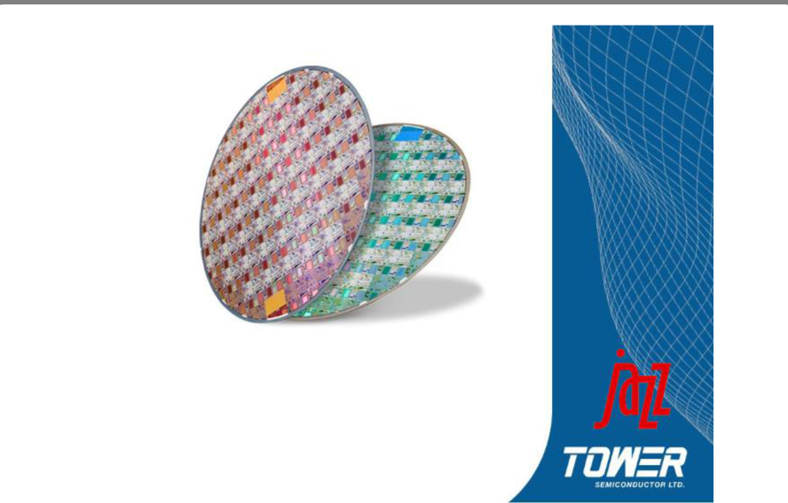

Tower Semiconductor

and

Jazz Technologies

Creating the Leading Specialty Foundry

Forward Looking Statements

The information presented today contains forward-looking statements that relate to anticipated future operating results. Those statements are based on management’s current expectations and assumptions, which may be affected by subsequent developments and business conditions, and necessarily involve risks and uncertainties. Therefore, there can be no assurance that actual future results will not differ materially from anticipated results.

For a discussion of risks and uncertainties that may affect the accuracy of forward-looking statements or which may otherwise affect our business, please see the information included under the heading "Risk Factors" in our most recent filings on Forms 20-F, F-1, F-3 and 6-K, as were filed with the Securities and Exchange Commission and the Israel Securities Authority

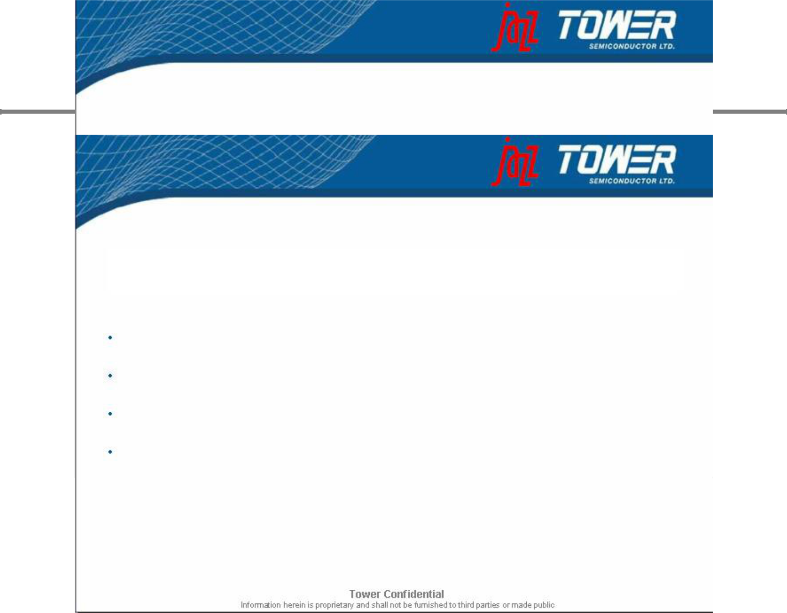
2

Transaction Overview

Tower Semiconductor has signed a definitive agreement to acquire Jazz Technologies in a stock-for-stock transaction

Jazz shareholders to receive 1.8 shares of Tower for each Jazz share

Implies $40 million in value based on Tower’s closing price of $1.16

Customary closing conditions including Jazz shareholder approval

Expected to close in 2nd half 2008

Merger is expected to create the leading pure-play specialty foundry and #7 overall pure-play foundry

3

Creating the Leading Specialty Foundry

Increased Capacity and Scale to Attract Larger Customers

Global Presence Improves Geographic Reach and Distribution

Leadership In Specialty Process Technologies:

CMOS Image Sensor, SiGe, Power Mgmt, NVM, RF-CMOS, BCD

Synergies of Value Add Technologies Enables Higher Margins

Diverse Customer Base in High Growth Markets

Significant Synergy Potential Both on Revenues and Expenses

4

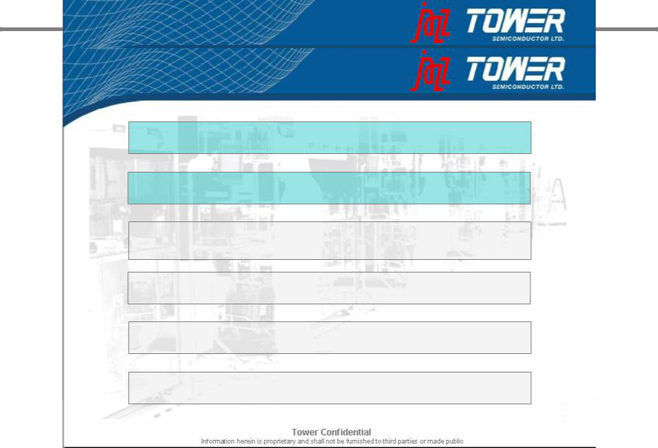
Creating the Leading Specialty Foundry

Increased Capacity and Scale to Attract Larger Customers

Global Presence Improves Geographic Reach and Distribution

Leadership In Specialty Process Technologies:

CMOS Image Sensor, SiGe, Power Mgmt, NVM, RF-CMOS, BCD

Synergies of Value Add Technologies Enables Higher Margins

Diverse Customer Base in High Growth Markets

Significant Synergy Potential Both on Revenues and Expenses

5
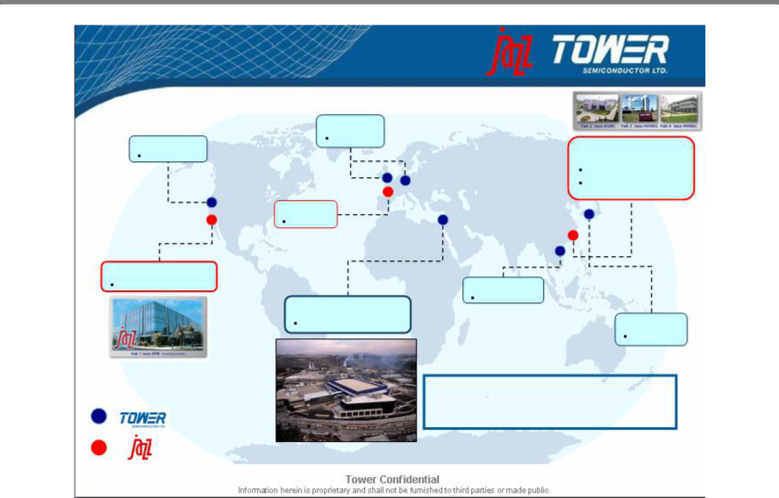

Global Infrastructure

 | UK & Holland
Santa Clara, CA | Sales reps

~70K WPY

Sales office | Shanghai, China
 | HHNEC: 10% ownership
 | ASMC: supply agreement
UK
Sales office
Newport Beach, CA
8” Fab | Hsinchu, Taiwan
 | Rep. office
Migdal HaEmek, Israel
8” Fab & 6” Fab | Tokyo,Japan
 | Rep. office
200K WPY
 | Total 8” equivalent capacity of
 | ~750K WPY
480K WPY

6

3rd Largest Pure Play Specialty Foundry
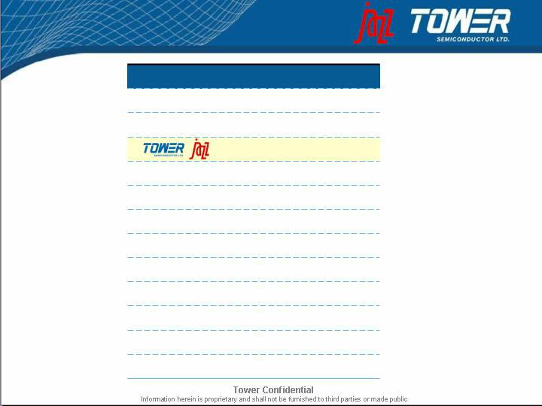

Company | 2007 Sales ($M)
Dongbu | $510
Vanguard | $486
 | $438
X-Fab | $410
SSMC | $350
HHNEC | $335
He Jian | $330
Grace | $214
Silterra | $185
ASMC | $170
Mosel Vitelics | $157
CSMC | $155 | Tower / Jazz is Pro Forma
 |  | Tower / Jazz is Pro Forma | 7
 |  | Source: IC Insights 5/2008 | 7
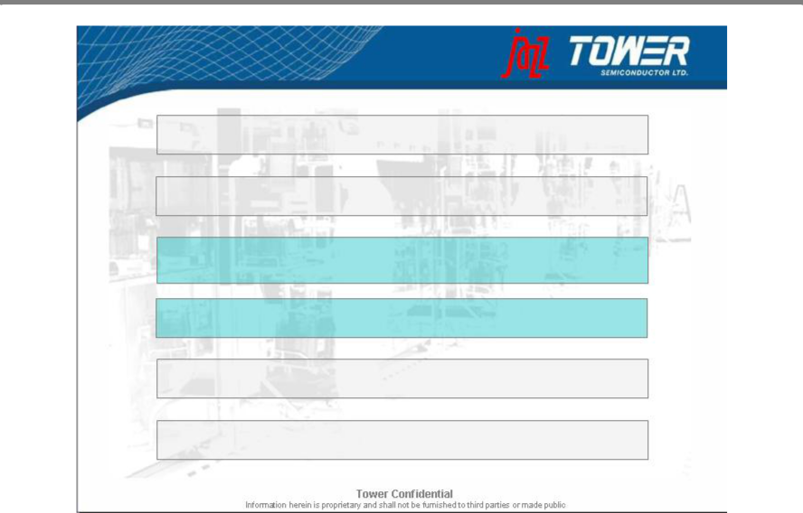

Creating the Leading Specialty Foundry

Increased Capacity and Scale to Attract Larger Customers

Global Presence Improves Geographic Reach and Distribution

Leadership In Specialty Process Technologies:

CMOS Image Sensor, SiGe, Power Mgmt, NVM, RF-CMOS, BCD

Synergies of Value Add Technologies Enables Higher Margins

Diverse Customer Base in High Growth Markets

Significant Synergy Potential Both on Revenues and Expenses

8

Post Merger Process Portfolio Lineup

 | From Jazz | From Tower | Tower/Jazz
 | Technology Node
0.50µm | 0.35µm | 0.25µm | 0.18µm | 0.16 / 0.13µm
 | BiCMOS, SiGe | SiGe | SiGe | SiGe
Power/ BCD (40V) | BCD (40V) | BCD (40V) | Power/BCD (40V)
 | RF CMOS | RF CMOS | RFCMOS | RF CMOS
Image Sensor | Image Sensor |  | Image Sensor
( X-Ray& Visible) | (X-Ray & Visible) |  | (X-Ray & Visible)
eNVM |  |  | eNVM
Mixed Signal | Mixed Signal | Mixed Signal | Mixed Signal | Mixed Signal
Digital CMOS | Digital CMOS | Digital CMOS | Digital CMOS | Digital CMOS
 |  |  |  | 9
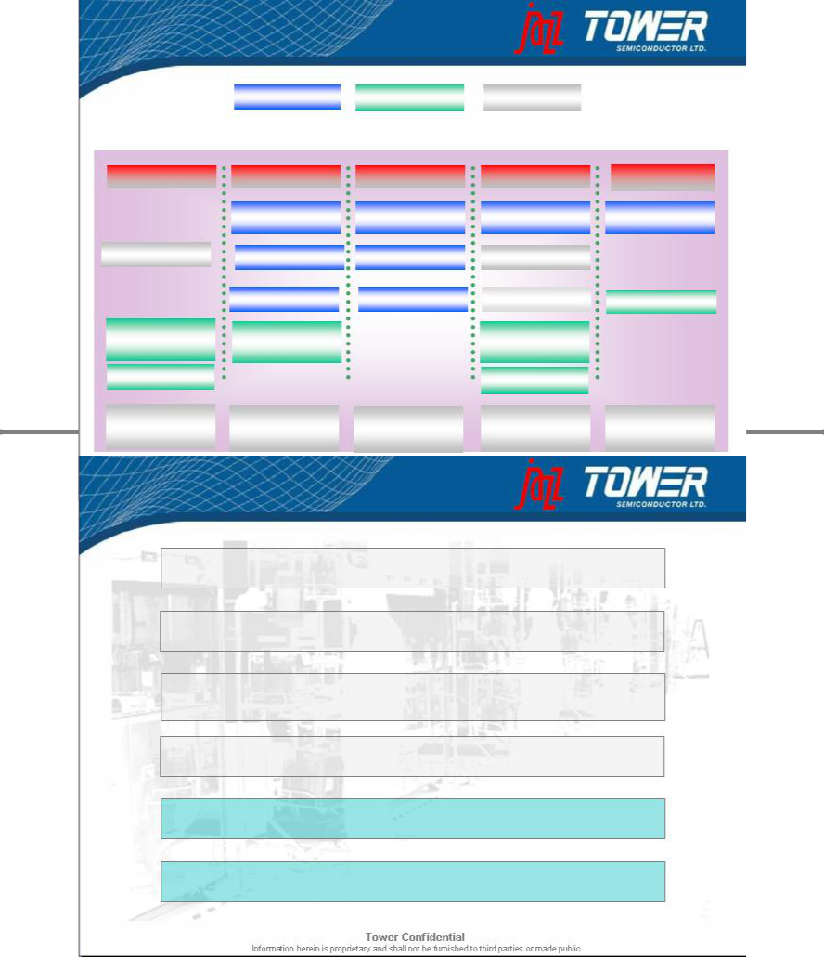

Creating the Leading Specialty Foundry

Increased Capacity and Scale to Attract Larger Customers

Global Presence Improves Geographic Reach and Distribution

Leadership In Specialty Process Technologies:

CMOS Image Sensor, SiGe, Power Mgmt, NVM, RF-CMOS, BCD

Synergies of Value Add Technologies Enables Higher Margins

Diverse Customer Base in High Growth Markets

Significant Synergy Potential Both on Revenues and Expenses

10

Foundry Revenue Growth Y/Y

 | 05vs04 |  | 06vs05 |  | 07vs06 |  | 07vs05
1 | Dongbu | 52% | Tower | 99% | X-Fab | 41% | Tower | 146%
2 | Others | 38% | Grace | 91% | CSMC Tech. | 36% | Grace | 114%
3 | SMIC | 20% | ASMC | 49% | Tower | 24% | X-Fab | 103%
4 | X-Fab | 14% | CSMC Tech. | 46% | Vanguard | 22% | CSMC Tech. | 99%

5 | He Jian | 9% | X-Fab | 44% | Silterra | 19% | Others | 55%
6 | SSMC | 8% | Chartered | 35% | Others | 17% | ASMC | 49%
7 | TSMC | 7% | Others | 32% | He Jian | 14% | Dongbu | 47%
8 | Chartered | 3% | Dongbu | 31% | Grace | 12% | Silterra | 42%
9 | Polar Semi. | -2% | SMIC | 25% | Dongbu | 12% | Vanguard | 37%
10 | CSMC Tech. | -3% | Silterra | 19% | Polar Semi. | 11% | SMIC | 33%
11 | HHNEC | -3% | TSMC | 19% | SSMC | 8% | He Jian | 32%
12 | ASMC | -9% | SSMC | 16% | Jazz | 8% | Chartered | 28%
13 | Jazz | -10% | He Jian | 16% | SMIC | 6% | SSMC | 25%
14 | Silterra | -13% | Vanguard | 13% | HHNEC | 6% | TSMC | 19%
15 | 1st Silicon | -15% | UMC | 13% | UMC | 2% | Polar Semi. | 17%
16 | UMC | -16% | Jazz | 7% | TSMC | 1% | Jazz | 16%
17 | Tower | -24% | Polar Semi. | 6% | Mosel-Vitelic | 1% | UMC | 15%
18 | Vanguard | -26% | HHNEC | 1% | ASMC | 0% | HHNEC | 7%
19 | Grace | -31% | 1st Silicon | NA | Chartered | -5% | Mosel-Vitelic | NA
20 | Mosel-Vitelic | NA | Mosel-Vitelic | NA | 1st Silicon | NA | 1st Silicon | NA
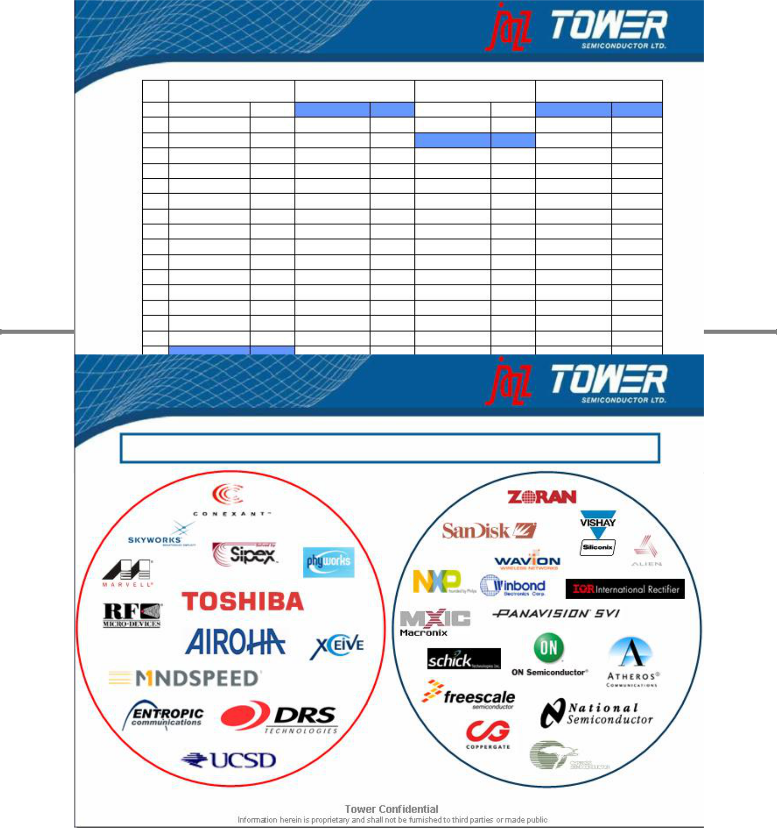

11

Source: The McLean Report, 2008 edition

Diverse Customer Base

No customer overlap out of the top 20 and only three out of the top 50

12

Combined Company Snapshot

Headquarters | Migdal Haemek, Israel
Ticker | TSEM (NASDAQ & Tel Aviv Stock Exchange)
Employees | 2,100
Fabs | Three fully owned (US and Israel), equity stake and partnership in
 | Chinese fabs - ~750,000 annual wafer capacity (8” equivalents)
Process | SiGe/BiCMOS 0.35 to 0.13u
Technologies | Analog CMOS/RFCMOS/BCD 0.8 to 0.16u
 | CMOS Image Sensor 1.0u - 0.18u
 | CMOS 1.0u to 0.13u

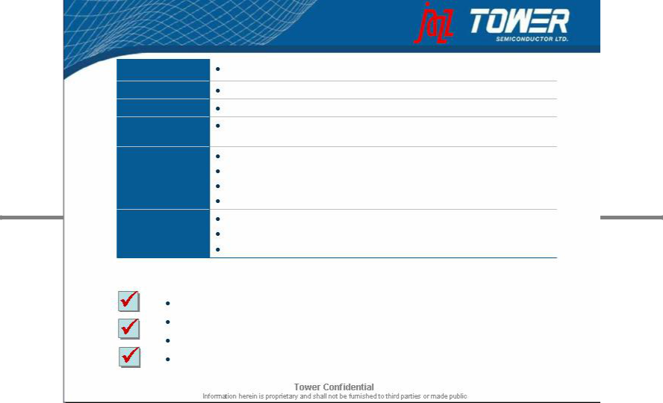
IP Leadership AIMS (Analog Intensive Mixed Signal)

PDK (Physical Design Kits)

Embedded Flash MTP&OTP Solutions

Key Financial Highlights

Combined trailing twelve months (TTM) revenues of $443 million

Impressive cash flow generation with $79 million of TTM EBITDA

Substantial, revenue and cost savings of up to $40 million annually

Improved leverage ratios

13

Forward-Looking Statements

This document contains forward-looking statements within the meaning of the “safe harbor” provisions of the Private Securities Litigation Reform Act of 1995, including statements concerning Tower’s proposed merger with Jazz. These statements are based on management’s current expectations and beliefs and are subject to a number of risks, uncertainties and assumptions that could cause actual results to differ materially from those described in the forward-looking statements. All statements other than statements of historical fact are statements that could be deemed forward-looking statements. For example, statements of expected synergies, customer benefits, costs savings, financial guidance, the timing of closing, industry ranking, execution of integration plans and management and organizational structure are all forward-looking statements. The potential risks and uncertainties include, among others, the possibility that the merger does not close or that the closing may be delayed, that expected customer benefits, synergies and costs savings will not be achieved or that the companies are unable to successfully execute their integration strategies, that the companies may be required to modify the terms of the transaction to achieve regulatory approval or for other reasons, that prior to or after the closing of the merger, the businesses of the companies may suffer due to uncertainty, as well as other risks applicable to both Tower’s and Jazz’s business described in the reports filed by Tower and Jazz with the Securities and Exchange Commission (the “SEC”) and, in the case of Tower, the Israel Securities Authority. These filings identify and address other important factors that could cause Tower’s and Jazz’s respective financial and operational results to differ materially from those contained in the forward-looking statements set forth in this document. Accordingly, no assurances can be given that any of the events anticipated by the forward-looking statements will transpire or occur, or if any of them do so, what impact they will have on the results of operations or financial condition of Tower or Jazz. Tower and Jazz are providing this information as of the date of this document and neither Tower nor Jazz undertakes any obligation to update any forward-looking statements contained in this document as a result of new information, future events or otherwise.

A more complete discussion of risks and uncertainties that may affect the accuracy of forward-looking statements included in this press release or which may otherwise affect Tower’s business is included under the heading “Risk Factors” in Tower’s most recent filings on Forms 20-F, F-3 and 6-K, as were filed with the SEC and the Israel Securities Authority. Future results may differ materially from those previously reported. Tower does not intend to update, and expressly disclaims any obligation to update, the information contained in this document.

Additional Information about the Proposed Merger and Where to Find It

In connection with the proposed merger, Tower intends to file with the SEC a Registration Statement on Form F-4 that will contain a Proxy Statement/Prospectus and related materials and Jazz expects to mail to its stockholders the final Proxy Statement/Prospectus containing information about Tower, Jazz and the proposed merger.

INVESTORS AND SECURITY HOLDERS ARE URGED TO READ THE PROXY STATEMENT/PROSPECTUS AND THE OTHER RELEVANT MATERIALS, CAREFULLY AND IN THEIR ENTIRETY, WHEN THEY BECOME AVAILABLE BECAUSE THEY WILL CONTAIN IMPORTANT INFORMATION ABOUT TOWER, JAZZ AND THE PROPOSED MERGER. Investors and security holders will be able to obtain free copies of the Registration Statement on Form F-4, the Proxy Statement/Prospectus and other relevant materials and documents filed by Tower or Jazz with the SEC, when they become available, through the web site maintained by the SEC at www.sec.gov. In addition, investors and security holders may obtain free copies of the documents relating to the proposed merger filed with the SEC by Tower by directing a request by mail to Tower Semiconductor Ltd, P.O. BOX 619, Migdal Haemek, Israel 23105, Attn: Investor Relations or by telephone at +972-4-6506936. Investors and security holders may obtain free copies of the documents relating to the proposed merger filed with the SEC by Jazz by directing a request by mail to Jazz Technologies, Inc., 4321 Jamboree Road, Newport Beach, California 92660, Attn: Investor Relations or by telephone at +1 415 445-3236.

Tower, Jazz and their respective executive officers and directors, under SEC rules, may be deemed to be participants in the solicitation of proxies from the stockholders of Jazz in connection with the proposed merger. Investors and security holders may obtain information regarding the special interests of these executive officers and directors in the proposed merger by reading the Proxy Statement/Prospectus filed with the SEC when it becomes available. Additional information regarding Tower’s executive officers and directors is included in Tower’s Form 20-F for the year ended December 31, 2006, which was filed with the SEC on June 25, 2007. Additional information regarding the executive officers and directors of Jazz is included in Jazz’s Proxy Statement for its 2008 Annual Meeting of Stockholders, which was filed with the SEC on April 7, 2008. These documents are available free of charge at the SEC’s web site at www.sec.gov and are also available free of charge from Investor Relations at Tower and Jazz by contacting Tower and Jazz as described above.

